UNT Lesson Plan Template

Pre-service Teacher: | Grade(s): | School/Mentor Teacher (if applicable):
 | *Kindergarten | Dr. Eutsler
Subject area(s):  Language Arts and Reading  Art | Unit Topic/Theme:  Phonemic awareness  Alliteration | Lesson Title: Creepy Carrots Alliteration
Find the TEKS, ELPS, and CCRS standards at this link:
http://www.teksresourcesystem.net/module/standards/Tools/Search
Relevant TEKS:  §110.2. English Language Arts and Reading, Kindergarten, Adopted 2017.  1) (B) restate and follow oral directions that involve a short, related sequence of actions  (ii) recognizing spoken alliteration or groups of words that begin with the same spoken onset or initial sound (ex. Creepy carrots)  *§117.102. Art, Kindergarten, Adopted 2017.  (b) Knowledge and skills  (2) Creative expression. The student communicates ideas through original artworks using a variety of media with appropriate skills. The student expresses thoughts and ideas creatively while challenging the imagination, fostering reflective thinking, and developing disciplined effort and progressive problem-solving skills | Relevant ELPS:  §74.4.D.2.B.i  are able to express simple, original messages, speak using sentences, and participate in short conversations and classroom interactions; may hesitate frequently and for long periods to think about how to communicate desired meaning. | Relevant TX CCRS:  CCSS.ELA-LITERACY.SL.K.1.B  Continue a conversation through multiple exchanges.
Lesson Objective(s)/Performance Outcomes
*Objectives:
The student can sequence story events by sorting illustrative story cards.
The student can identify the use alliteration.
The student can construct their own object with various materials.
Performance Outcomes:
Students will be end to sequence events from beginning to end.
Students will be able to identify alliteration.
Students will be able to construct their own design.

Assessment (Description/Criteria)
*Formative:
Ask questions before, during, and after the story. Ask the students to make predictions about the story and what will happen next.
Questions
Before:
What do you think this story is about?
What do you think creepy mean?
Have you ever been scared before?
During:
Why do you think the carrots are following him? (page "until they started following him")
Why do you think Jaspers parents don't believe the carrots are following him?
After:
Why do you think the carrots didn’t want Jasper in their patch?
What else could the carrots have done other than to scare him?
Materials and Resources
Book:
- Creepy Carrots
Activities:
- http://mrswillskindergarten.com/creepy-carrots-lesson-plans/
- https://www.teacherspayteachers.com/Product/Alliteration-Worksheet-398916

Other Materials:
- Construction paper
- Scissors
- Crayons
- Small plastic containers (no lids)
- String
- Smaller ruler
- Paper clips

Management of the Instructional Environment
Start the students with sitting in a circle while Creepy Carrots is read.
Divide students into groups and begin centers.
*The students will be divided into groups of five for centers.
They will rotate centers with three of the centers being the activities below.
Technology Integration
*Use the smartboard in the classroom to display the book. The students will be able to view the illustrations and the words in a larger format. Point to the words as they are read aloud.
Diversity and Equity (Accommodations, Modifications, Adaptations)
Read the story twice and discuss any new words in the story the ELLs may be hearing for the first time.
Words include:
- Creepy
- Sinister
- Crisp
- Ripped
In the story ask the children what the words mean. Help define the words if needed while reading the story.
Activities/Procedures
*Read Aloud:
- Project the book on the smartboard and read through Creepy Carrots. Before, during, and after the story ask questions.
- Point to the words as they are read.
- Once the story is finished ask questions to the students that are listed above.
Reading
- Sequencing the order of the story. The pictures from the story will be out of order and the students will place them in order from the beginning of the story to the end.
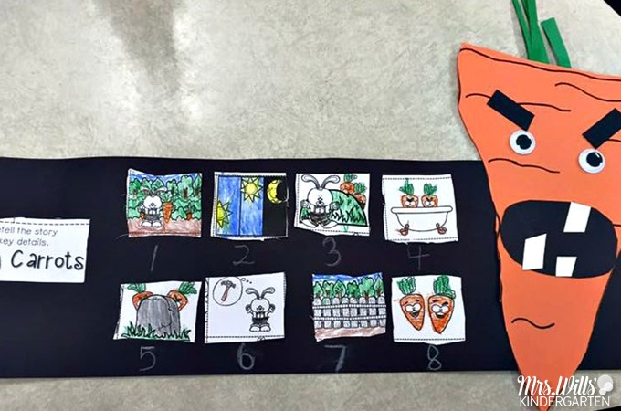
http://mrswillskindergarten.com/creepy-carrots-lesson-plans/

Art:
- Creepy Carrot trap: Have cut carrots for the students and materials in which the students can make their own traps for their creepy carrots.
Materials:
-paper clip
-plastic containers
-smaller rulers
-string
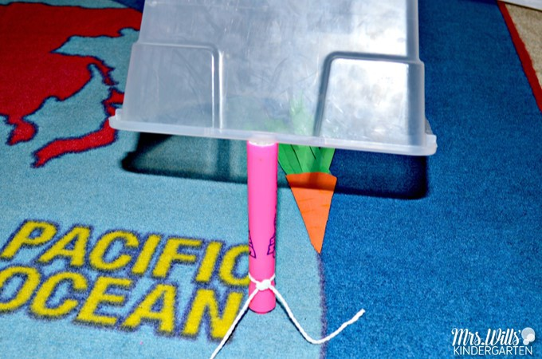
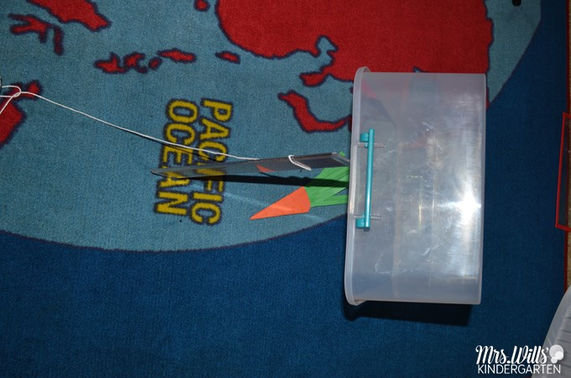

*Literacy:
- The students will be able to practice identifying alliteration with this sheet. This will be set up at a center for them to do.
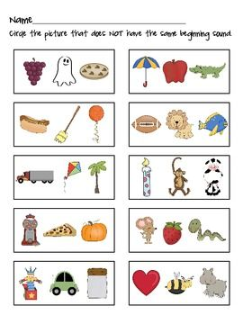

Reflections and Documentation/Evidence of Lesson Effectiveness:
*Creepy Carrots is a book that can introduce students to alliteration. Throughout the story, the students hear the term “Creepy Carrots” various times and it brings a vivid image beyond the pictures in the book. I thought it would be a good book to introduce alliteration to students. Along with that I wanted them to be able to sequence the story with the story board. The art activity is fun because it allows students to design their own creepy carrots trap. They design their own trap to allow for creativity and critical thinking. They can think about how they want to set up their trap for their creepy carrots. I can see with the story board if the children are able to think back and sequence. The alliteration worksheet they can circle the picture that doesn't circle the matching sound. I revised my lesson and changed the literacy activity. When I went through the plan and changed what was suggested. Revising it allowed me to see how much was lacking from my plan and the improvements that could be made.

