Lesson Plan 1

Pre-service Teacher: | Grade(s): 3rd grade | School/Mentor Teacher (if applicable):  Dr. Eutsler
Subject area(s): Social Studies and Language Arts and Reading | Unit Topic/Theme:  Creative writing, narrative writing, and identifying how people can impact their communities | Lesson Title: How Can You Help Your Community
Find the TEKS, ELPS, and CCRS standards at this link:
http://www.teksresourcesystem.net/module/standards/Tools/Search
Relevant TEKS:  §113.14. Social Studies, Grade 3, Beginning with School Year 2011-2012  (b)Knowledge and skills.  (12) Citizenship. The student understands the impact of individual and group decisions on communities in a constitutional republic. The student is expected to: (B) identify examples of actions individuals and groups can take to improve the community;  §110.5. English Language Arts and Reading, Grade 3, Adopted 2017.  (b) Knowledge and skills  (7) Response skills: listening, speaking, reading, writing, and thinking using multiple texts. The student responds to an increasingly challenging variety of sources that are read, heard, or viewed. The student is expected to:  (B) write a response to a literary or informational text that demonstrates an understanding of a text; | Relevant ELPS:  (c) Cross-curricular second language acquisition essential knowledge and skills.  (3) Cross-curricular second language acquisition/speaking. The ELL speaks in a variety of modes for a variety of purposes with an awareness of different language registers (formal/informal) using vocabulary with increasing fluency and accuracy in language arts and all content areas. ELLs may be at the beginning, intermediate, advanced, or advanced high stage of English language acquisition in speaking. In order for the ELL to meet grade-level learning expectations across the foundation and enrichment curriculum, all instruction delivered in English must be linguistically accommodated (communicated, sequenced, and scaffolded) commensurate with the student's level of English language proficiency. The student is expected to:  (G) express opinions, ideas, and feelings ranging from communicating single words and short phrases to participating in extended discussions on a variety of social and grade-appropriate academic topics; | Relevant TX CCRS:  Social Study Standards  I. Interrelated Disciplines and Skills  A. Spatial analysis of physical and cultural processes that shape the human experiences  2. Analyze the interaction between human communities and the environment.
Lesson Objective(s)/Performance Outcomes
Objectives:
How do individuals impact communities?
What can the students infer from reading “Extra Yarn”?
How can the students impact their own communities?

Performance Outcomes:
Students will be able to identify the impact people have on communities by reading Extra Yarn by Mac Barnett
Students will able to write their own versions/ending to the story Extra Yarn
Students will discuss in small groups what kind of impacts they are they making on their community

Assessment (Description/Criteria)
Formative: Ask the student’s before reading the story their prior knowledge of communities. Have a couple of students think and share what they think a community is. Have a couple of them come up to the whiteboard and write their ideas. Teacher will leave ideas on the board so they can all look back after reading the story. During the reading, students will use their mini white boards to write/draw their thoughts when teach pauses and asks them to do so.

After reading the story, collect each student’s paper they wrote about their own version/ending of Extra Yarn. This will give the teacher an idea on who is struggling with developing their ideas, sentence structure, and see who understood the text. During the small group discussions, the teacher should sit in with each group and make notes on the student’s thoughts on what kind of impacts their having on their communities.
Materials and Resources
Book
- Extra Yarn by Mac Barnett
Activities
- https://www.pinterest.com/pin/283445370277391180/
- https://www.pinterest.com/pin/222928250284456229/
- http://conversationsinliteracy.blogspot.com/2016/01/interactive-read-aloud-tips.html

Other Materials
- Mini Whiteboards
- Dry Erase markers
- Paper
- Pencil
- Handout with different types of narrative endings
- IPad
- Computer
- Projector

Management of the Instructional Environment
Students will start off in sitting on the front rug while we read the story.
When finished with the story, the teacher will put the students into small groups to discuss what kind of impacts they are making on their communities and create a image on the Story Creator app of what their own community would look like.
When finished with discussions, teacher will have students go back to their seats and have them write their own version/ending to the story Extra Yarn.
Technology Integration
An IPad for the students to use during their small group discussions where they can use the app Story Creator to create their own version of a community. Also a computer and projector to pull up the instructions for the small group discussions.

Diversity and Equity (Accommodations, Modifications, Adaptations)
Provide pictures for words used through out the lesson that ELLs might now know posted on the whiteboard before the teacher starts the story. While reading, make sure to pause and check for understanding. Also check their whiteboards when you have them pause and think while you are reading. Assist ELLs while they are working on their own version/endings of the story when needed.
Activities/Procedures
Before Reading
- Teacher will ask the student’s prior knowledge about communities
- Have students think and share what they think a community is
- Ask a couple of students to share and come up to the white board and write down some of their ideas
- Hand out a mini whiteboard to each student and a marker. Explain to them that while reading, the teacher will stop and pause and have the students write/draw their ideas or thoughts at that part of the story and then share. (http://conversationsinliteracy.blogspot.com/2016/01/interactive-read-aloud-tips.html)
Read
- Extra Yarn by Mac Barnett
During Reading
- Ask students through out the book to pause and write/draw their ideas and thoughts on the mini whiteboard and have them all hold them up once finished each time they pause.
- Have 2 to 3 students share their thoughts after each pause.
After Reading
- Refer back to the white board of the student’s ideas they thought of before the reading. Discuss as a whole about their ideas now after they read the story.
Social Studies
Group Activity
- Arrange students into small groups for discussion.
- Pull up on the computer and display on the projector the directions for the small group discussion. The directions will tell students to discuss what kind of impacts they are making on their community and how to create a picture of their own community on the Story Creator app.
- The teacher will explain to all the students that they will discuss the question and then using an IPad (one per group) and the app Story Creator to draw what their community would look like.
- Give the students around 20 minutes to discuss and draw their image.
- After the time is up, have each group stand and present their drawing and explain their ideas on what kind of impacts they are making on their communities.

Language Arts
Individual Activity
- Teacher will send the students back to their seats.
- Teacher will then explain to the students they will be creating and writing their own version/ending to the story they read.
- Teacher will then ask the students if they know the different types of endings for stories.
- Have students pair and share and turn to their shoulder partner and have them discuss for about one minute.
- Ask a couple of students to share.
- Pass out the sheet that gives the students the type of narrative endings with explanations.

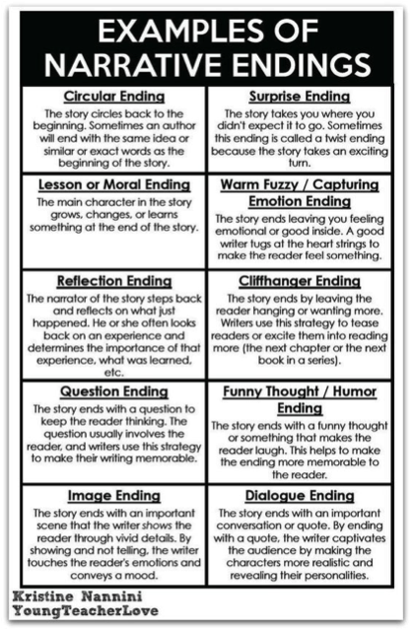

- Have the students use this as a reference in helping them write their own endings.
- Hand out sheets of paper to each student.
- Give the students 30 minutes to write their own version/ending.
- As the students are working, the teacher should walk around and monitor the student’s progress and assist those when needed.
- As students start to finish, have them hand the sheet to the teacher and start putting each paper on the wall under a picture of each student, so they know who the writings belong to. This way the students can display their creative writing and for others to see (modified idea) (https://www.pinterest.com/pin/222928250284456229/)

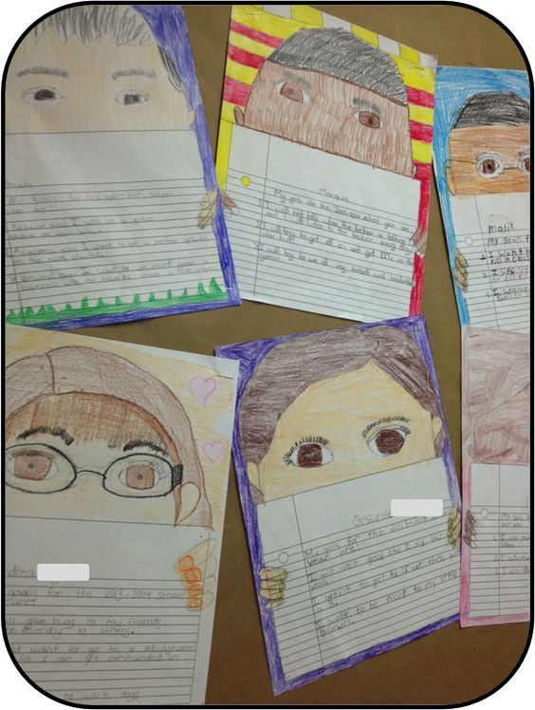

Closing The Lesson
- For closing the lesson, the teacher will go back over how we as people can impact our communities.
- Have the students share their version/endings of the stories if the students would like to.

Reflections and Documentation/Evidence of Lesson Effectiveness
I decided to use this story because it is a great way to incorporate social studies, as well as writing and speaking skills into the lesson. It is important for children to know about their own communities and things they can do to get involved. Even just a little goes a long way. I wanted to incorporate a discussion into the lesson because it is good for children to voice their opinions and be able to share them with others, as well as building confidence when speaking with others. Having the children write their own version/endings of the story gives them the opportunity to express their creativity and build on their writing skills, which to me is very important.

