UNT Lesson Plan Template
Pre-service Teacher: | Grade(s): 2nd | School/Mentor Teacher (if applicable):
Subject area(s):  Reading/Writing | Unit Topic/Theme:  Communication Skills | Lesson Title:  My Mouth Is A Volcano
Relevant TEKS:  110.13. B.6.A -identify moral lessons as themes in well-known fables, legends, myths, or stories;  110.13. B.5.B use context to determine the relevant meaning of unfamiliar words or multiple-meaning words; | Relevant ELPS:  §74.4.C.2.C  Learn new language structures, expressions, and basic and academic vocabulary heard during classroom instruction and interactions;  §74.4.D.2.B.i are able to express simple, original messages, speak using sentences, and participate in short conversations and classroom interactions; may hesitate frequently and for long periods to think about how to communicate desired meaning. | Relevant TX CCRS:  Writing B1  Understand new vocabulary and concepts and use them accurately in reading, speaking, and writing. Identify new words and concepts acquired through study of their relationships to other words and concepts.  Reading across the curriculum A2  Use a variety of strategies to understand the meanings of new words.
Lesson Objective(s)/Performance Outcomes
Objectives:
- What can we do when we feel like we may interrupt someone?
- What communication skills did the main character learn by the end of the book?
Performance Outcomes:
- Students will be able to identify vocabulary words from the book.
- Students will be able to use vocabulary words in a sentence.

Assessment (Description/Criteria)
Formative Techniques: Discussions questions will be asked throughout the read aloud referring back to the vocabulary. The students will be asked to make predictions about the book before the reading. The teacher will pay attention to those who participate in the questions. Student’s will turn to their side buddies and discuss situation throughout the read aloud, the teacher will observe the children during this time.

Summative Techniques: Student’s will be asked to use each vocabulary word discussed in the read aloud in a sentence. Students will write their sentences in their writing journal. The teacher checks the journals at the end of each week. There will be a poster board at the front of the class with the words written on it if students need something to refer back to.

Materials and Resources
My Mouth Is A Volcano by Julia Cook
Large Markers
Poster Board
Writing Journals
Projector
What can I do if I am going to erupt? (worksheet)

Management of the Instructional Environment
Students will sit on the carpet at the beginning of lesson for introduction of vocabulary and the read aloud of My Mouth Is A Volcano. After shared reading and discussion of vocabulary students will return to their desks to write in their writing journals. The student will also participate in an activity over the book during writing centers.

Technology Integration
The teacher will use the projector to show the illustrations of the book while the teacher is reading. The teacher will use a pointer to read the book on the projector so that the student’s can follow along.
During centers student’s can use the seesaw application on the Ipads to share a time that they could relate to the book, My Mouth Is A Volcano.

Diversity and Equity (Accommodations, Modifications, Adaptations)
For ELLs student the teacher will provide labeled pictures of the new vocabulary. The teacher will state the overall objective before starting the lesson and will have the objectives written on the white board before hand. For children who need extra time to reading or following along the teacher can stay on each page of the book for extra time. Student’s who have a hard time verbally expressing their thoughts can bring their writing journals to the carpet and answer the questions in writing.

Activities/Procedures
Before: The teacher will read the overall objectives to the class that will be written on white board before hand. The teacher will show students the cover of the book and ask them to predict what they think that book will be about. The teacher will tap into background knowledge by asking the class to close their eyes and think of a time that they could not hold in what they wanted to say, the teacher will then allow a few children to share their experiences. The teacher will then write on a poster board the key vocabulary words using visuals to help the children understand each meaning. After going into detail about each key vocabulary word the teacher will begin the reading.

Key Vocabulary:
Volcano- an opening in the earth’s crust through which melted rock, ash and gassed are forced out.
Patiently- able to wait without complaining or becoming upset
Erupt- to break or burst suddenly
Interrupted- to begin to speak over, in the middle of, in a way that breaks off
Emergency- a serious situation or sudden crisis that calls for fast action
Rumble- to make a long, low, rolling sound

During: The teacher will begin to read the book aloud to the class, stopping at the key vocabulary words to reiterate the definitions. During the read aloud the teacher will stop to ask the student critical thinking questions. During the reading the teacher will use another poster board and draw a volcano on it, each time that the main charter learns a new strategies to do instead of interrupting the teacher will write it on the poster (be patient, be polite, remember their thoughts, continue to think, take a breath, wait until their finished and raise their hand). The teacher will also allow student to come up with their own strategies to write on the poster board.
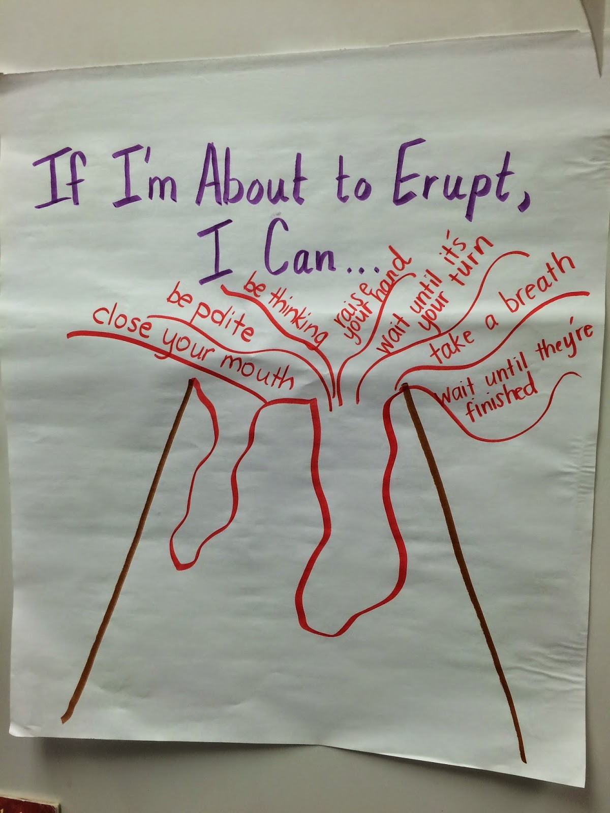

After: After the read aloud the teacher will ask the class, What the lesson did the main charter learn in the book? Turn to your side buddy and discuss. The teacher will allow time for their students to discuss with their buddies. After discussing the theme of the book, the teacher will go over the key vocabulary one more time. The teacher will then tell the class to go back to their desks and pull out their writing journal. The class will be prompted to write each new vocabulary in a sentence in their journals. The teacher will also give the classthe option to share a time that they can relate to the book during centers using the seesaw on the Ipads.

Addition Activity: Another activity that can be added to the writing centers is the worksheet what can I do when I feel like I am going to erupt. The children can write two to three sentences about what they learned from the book and color the volcano. The book My Mouth Is A Volcano will be placed at this center so the children can refer back to the text if needed.

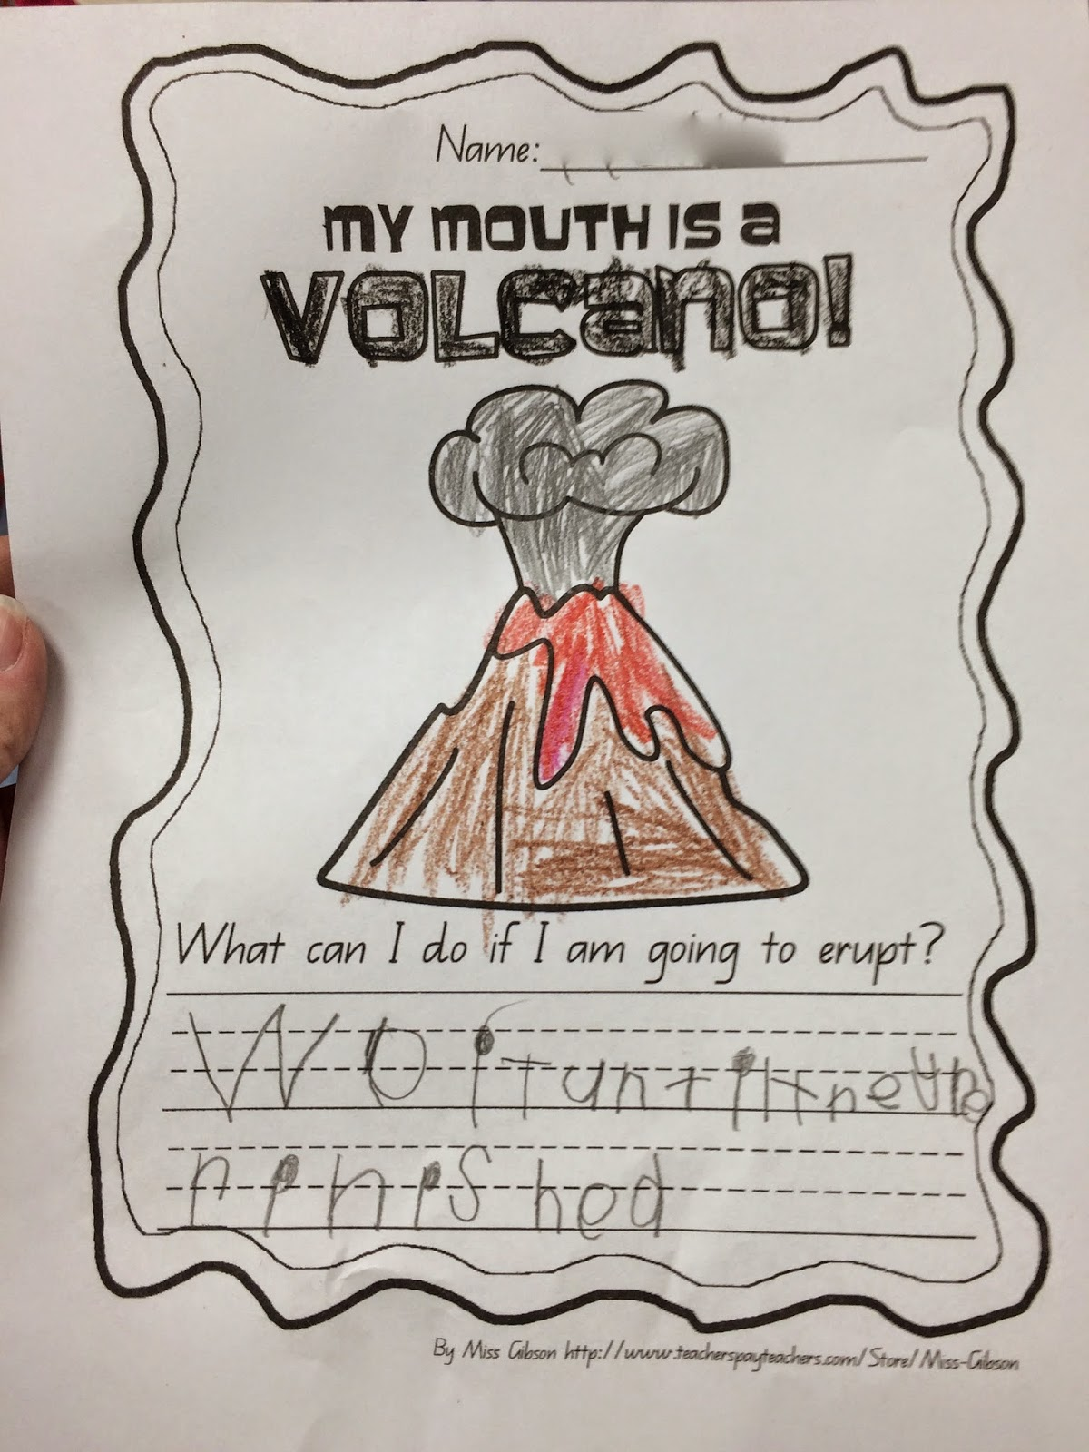

Reflections and Documentation/Evidence of Lesson Effectiveness
I think that the book My Mouth Is A Volcano is a great book to read at the beginning of the school year when students are still learning the classroom procedures. This book has exciting vocabulary and there are many different lessons that the children can learn from the shared reading. I think that it is important for children to use background knowledge and think about their own experiences during this reading because I am sure that every child in the classroom can relate to this book in some way. The illustration in this book will keep the children engaged and the text on each page is not too wordy to it will be easy for the children to follow along on the projector.

