UNT Lesson Plan Template

Pre-service Teacher: S. Bonavita | Grade(s): 4th Grade | School/Mentor Teacher (if applicable):
Subject area(s): ELA and SS | Unit Topic/Theme: The Holocaust | Lesson Title: Number the Stars Lesson (Day One)
Find the TEKS, ELPS, and CCRS standards at this link:
http://www.teksresourcesystem.net/module/standards/Tools/Search
Relevant TEKS:  ELA 4.1(A): Students read grade-level text with fluency and comprehension. Students are expected to:  (A) Read aloud grade-level stories with fluency (rate, accuracy, expression, appropriate phrasing) and comprehension.  SS 4.5(A): The student understands important issues, events, and individuals of the 20th century in Texas. The student is expected to:  (A) Identify the impact of various issues and events on life in Texas such as urbanization, increased use of oil and gas, the Great Depression, the Dust Bowl, and World War II. | Relevant ELPS:  ELPS.c.4J: Demonstrate English comprehension and expand reading skills by employing inferential skills such as predicating, making connections between ideas, drawing inferences and conclusions from text and graphic sources, and finding supporting text evidence commensurate with content area needs. | Relevant TX CCRS:  ELA:  E/LAS.IV.A.3: Use a variety of strategies to enhance listening comprehension (e.g., focus attention on message, monitor message for clarity and understanding, providing verbal and nonverbal feedback, note cues such as change of pace or particular words that indicate a new point is about to be made, select and organize key information).  SS:  E/LAS.II.C.3: Analyze works of literature for what they suggest about the historical period and cultural context in which they were written.
Lesson Objective(s)/Performance Outcomes
Objectives:
What can students predict will happen in the next chapter?
What differences can the students infer between Annemarie and Ellen?
Performance Outcome:
The student will be able to recognize his or her own ability to work for justice and make a difference in one's own society and culture.

Assessment (Description/Criteria)
Formative: Ask descriptive questions at the before, during, and after the chapters have been read. While reading out-loud, stop to make sure the students are grasping the content that is being discussed and have them make predictions.
Summative: Collect the students’ ‘Character Map’ booklets and determine if they are grasping the distinctive characteristics of the characters. Notice if they are using vivid descriptors or just basic information to determine which students need ‘extra’ help.

Materials and Resources
Book:
Number the Stars by Lois Lowery
Activities:
- Character Map: http://www.storyboardthat.com/storyboards/beckyharvey/number-the-stars--fast-character-map (ELA)
- Character Jeopardy: https://www.teachervision.com/world-war-ii-1939-1945/number-stars-character-jeopardy (ELA)
- Mapmakers: https://www.prestwickhouse.com/samples/201559.pdf (SS)
Other Materials:
- Computer

Management of the Instructional Environment
In English- Language Arts:
Students will start off in their ‘reading places’.
After the chapters have been read, students will go to their reading groups and work for about 15 min. on their character maps.
Once done, students will participate in the class activity ‘Jeopardy’ to assess their understanding and knowledge of what has been covered.
In Social Studies:
Students will fill out their Mapmakers Activity in small groups.
Once done, it will be discussed as a class.
Technology Integration
The character Jeopardy Activity incorporates the website TeachTech which imitates a class jeopardy game.

Diversity and Equity (Accommodations, Modifications, Adaptations)
Go over new vocabulary before we begin to read our chapters. Stop throughout and check for understanding.

Activities/Procedures
Read:
Chapters One and Two of Number the Stars by Lois Lowery (Out loud as a class)
Discussion:
Before:
Has any read this book before?
Can someone tell me what we already discussed when we speak about the holocaust?
During:
Why is it important that Annemarie speaks to the soldiers instead of Ellen?
Why do the girls have to take two different routes to school after their encounter with the soldiers?
What could have caused the change that Annemarie thinks about when she is remembering her conversation with her father?
After:
When Ellen and Annemarie were stopped by soldiers, Annemarie did most of the talking. How could the situation have been different if Ellen decided to take charge of the conversation?
Why do you think Annemarie believes that Fairy Tales are the only things that will never change?
Reflections and Documentation/Evidence of Lesson Effectiveness
I really enjoyed writing this lesson plan because it was in-depth. I really liked that I could incorporate Social Studies into the lesson because it gave me insight on how to expand my lesson plans over multiple subjects.
Reflecting on the lesson plan, I would probably choose a non-chapter book. Since it is seven-teen chapters, it makes it much more difficult to plan a lesson for 90 minutes. To combat that, I decided to look at this lesson in terms of days. Meaning, this would-be day one and I would continue to work and read the book with my students throughout the next few weeks.

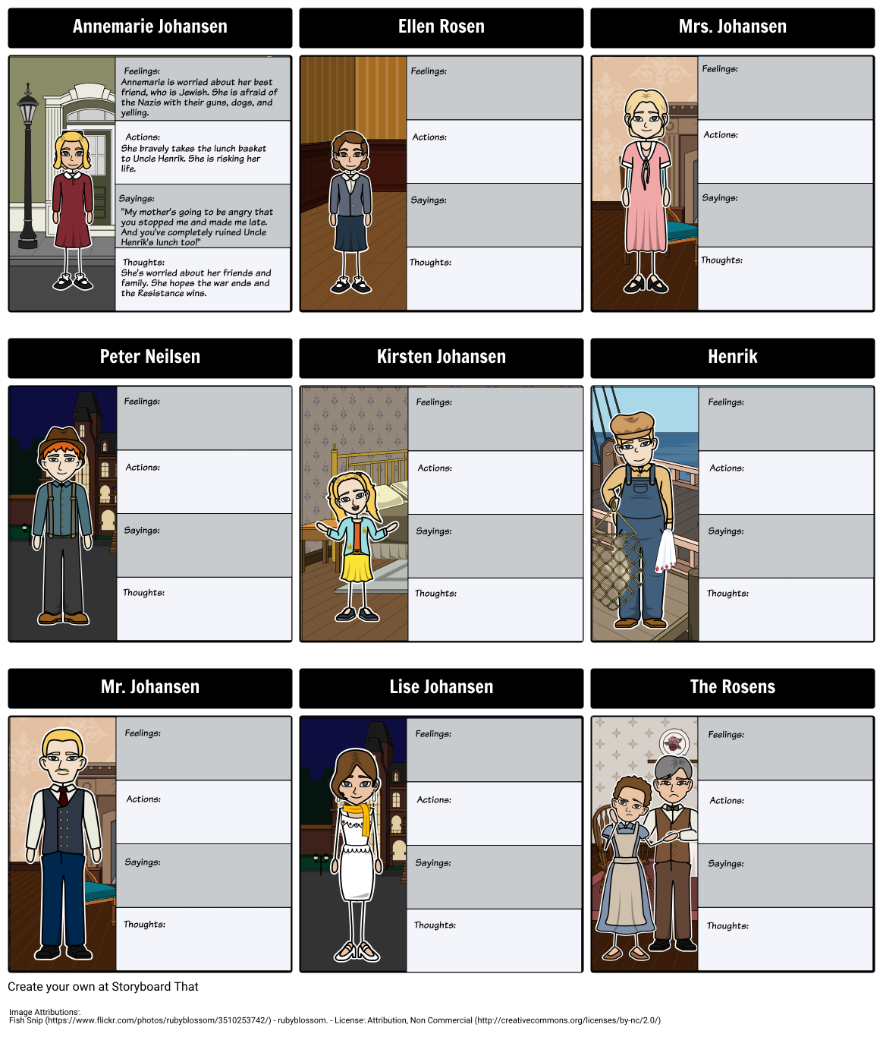
Character Map Activity (ELA)
http://www.storyboardthat.com/storyboards/beckyharvey/number-the-stars--fast-character-map
Students will be filling out these charts as new characters and situations are introduced.
Character Jeopardy Activity (ELA)
https://www.teachervision.com/world-war-ii-1939-1945/number-stars-character-jeopardy
https://teachtech.westernu.edu/playing-jeopardy-on-turningpoint/
Character Jeopardy for Number the Stars will be used as an assessment tool to see how much the students are grasping from the novel.
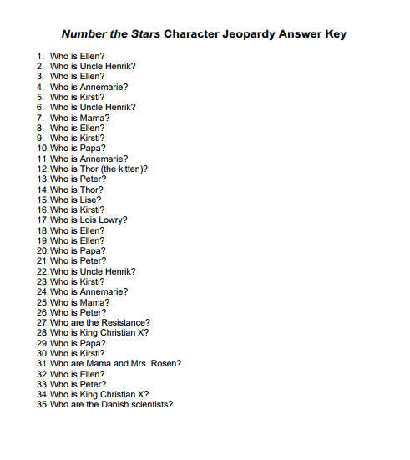
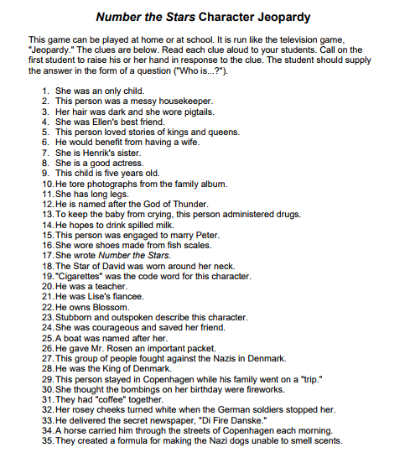
Mapmakers Activity (Social Studies)
https://www.prestwickhouse.com/samples/201559.pdf
The students will color and label a map of Europe locating Denmark, Copenhagen, Germany, and Sweden.
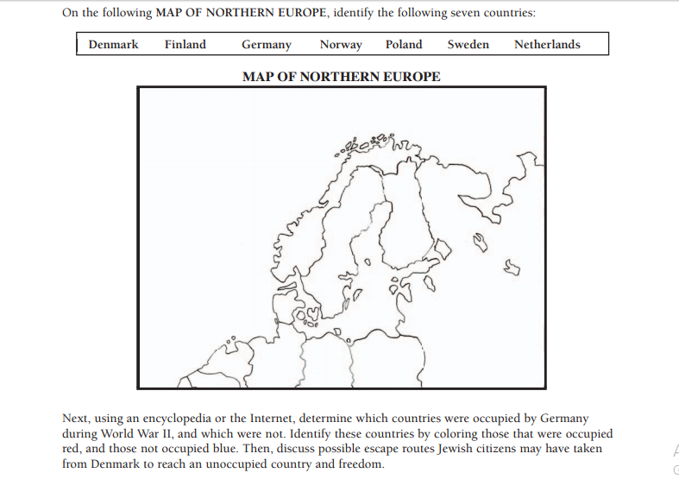
Book Information
Number the Stars by Lois Lowery (1989)
Grade Level: 4th-6th
Notable Awards:
1. John Newbery Award
2. Dorothy Canfield Fisher Children's Book Award
3. National Jewish Book Award for Children's Literature
“Lowry's Number the Stars is a simple yet poignant novel about a young girl's contribution to the resistance movement in Denmark during World War 11. Annemarie Johansen, a 10-year old girl living in Copenhagen, is faced with the knowledge that the Nazis are beginning to "relocate" the Jews in her city. Ellen Rosen, a neighbor and classmate of Annemarie's, is Jewish. Through a series of small acts of bravery, Annemarie and her family help the Rosens escape into neighboring Sweden, in a boat with a false bottom, operated by Annemarie's Uncle Henrik. Annemarie is called upon to ensure the Jews' safe passage when she must deliver a package to Henrik, in the dark, because her mother has broken her ankle and cannot walk. Annemarie successfully delivers the package, and only later learns what could have happened had she not been able to dodge the soldiers who stop her in the woods. Once the war is over, Annemarie's parents tell her that her older sister, Lise, was part of the resistance movement and was killed for it. Annemarie realizes that she too, has helped Jews escape and feels proud to know and be friends with Ellen, even though she doesn't know if she'll ever see her friend again. At the end of the book, Annemarie decides to wear Ellen's Star of David necklace, as a sign of her friendship, until Ellen returns and can wear it herself’.
~ Gwen Gray
