UNT Lesson Plan
Pre-service Teacher:  Lydia Allen | Grade(s):  2nd | School/Mentor Teacher (if applicable):  Dr. Eutsler
Subject area(s):  Reading and Writing | Unit Topic/Theme:  Persuasive text and sensory language | Lesson Title:  Persuasive text and sensory language in Tales for Very Picky Eaters (food frenzy)
Relevant TEKS:  110.13. B.  (11)Reading/Comprehension of Literary Text/Sensory Language. Students understand, make inferences and draw conclusions about how an author's sensory language creates imagery in literary text and provide evidence from text to support their understanding. Students are expected to recognize that some words and phrases have literal and non-literal meanings (e.g., take steps).  (20) Writing/Persuasive Texts. Students write persuasive texts to influence the attitudes or actions of a specific audience on specific issues. Students are expected to write persuasive statements about issues that are important to the student for the appropriate audience in the school, home, or local community. | Relevant ELPS:  §74.4.C.5.B  write using newly acquired basic vocabulary and content-based grade-level vocabulary;  §74.4.C.3.B  expand and internalize initial English vocabulary by learning and using high-frequency English words necessary for identifying and describing people, places, and objects, by retelling simple stories and basic information represented or supported by pictures, and by learning and using routine language needed for classroom communication; | Relevant TX CCRS:  Writing A4  Recognize the importance of revision as the key ideas and organize them more logically effectively, and draw the reader to the author’s purpose.  Reading A6  Analyze imagery in literary texts.
Lesson Objective(s)/Performance Outcomes

Objectives:
In his book Tales of Picky Eaters how does Josh Schneider use sensory language to describe how James feels about certain foods?
Using sensory language how would you describe what your favorite food looks and taste like to your classmates?
How can persuasive text change your opinion on a particular topic?
How can revising your work help the reader fully understand your writing?

Performance Outcomes:
Students understand how authors use sensory language to create images
Students understand that persuasive texts influence the opinions of their audience
Students will be able to organize/revise their work to effectively draw the reader to their purpose

Assessment (Description/Criteria)
Formative technique(s):

- During the reading, questions will be asked about the sensory language used, textual evidence, and the vocabulary. The teacher will observe these answers and conversations during small groups to assess where the children are.
- Students will use a learning log everyday to respond to either a prompt I provide for them or to reflect on a certain topic. For this specific assignment I want the students to first reflect about their favorite and least favorite foods.
- Then the days to follow the students will begin practicing persuasive texts by writing about their favorite food specifically. With the goal to get their peers to try their favorite foods.
- I will collect the student’s persuasive writing and assess the various areas of literacy. Checking vocabulary, their evidence, etc.

Materials and Resources
Book:
Tales for very picky eaters by Josh Shneider

Activities:
Story creator on Ipads
Handouts
Flashcards

Other materials:
Markers
Cardstock
Crayons

Management of the Instructional Environment

Students will start off in a large circle on the rug while we read the story. Then we will move into individual time to reflect in their journals regarding their own opinions. Then the class will discuss in small groups about their favorite and least favorite foods. We will then recreate the story using (the Ipads) their own favorite and least favorite foods with a small group. Once that is complete the students will volunteer to share their own stories. After that they will begin writing their own persuasive writings individually which we will continue to work on throughout the week. We will then end in centers each pertaining to either vocabulary form the book, practicing sensory language, or coloring.

Technology Integration
In small groups the students will use the app story creator on the Ipads to create their version of Josh Schneider’s tale.
Diversity and Equity (Accommodations, Modifications, Adaptations)

In my classroom we have 12 ELL’S out of 25. So vocabulary and stating clear goals are important.
At the beginning of the lesson the teacher will provide the students with clear objectives and learning goals.
For ELLs student the teacher will provide labeled pictures of the new vocabulary. For children who need extra time to reading or following along the teacher can stay on each page of the book for extra time. For students who have difficulty expressing themselves through words, they can bring their writing journal to the small group to provide answers through writing, but will be challenged to express those thoughts verbally. During centers flashcards will be provided for vocabulary and any questions the students have will be answered. All instruction will also be written out.

Activities/Procedures
Before instruction the teacher will have clear objectives and goals written out on the board. All centers will be ready to go with all materials
- Vocabulary flashcards (Set for at least 5 students)
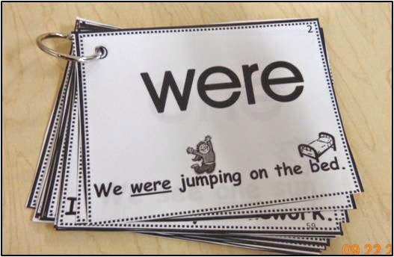

- Sensory language chart
This chart will use words form the book pertaining to each sense
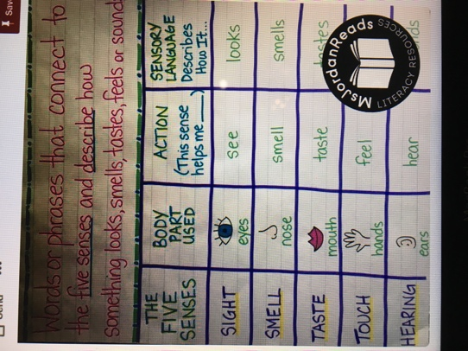
- Would you rather
This will be used to get students forming sentences expressing their opinions through the use of our current vocabulary and sensory language.
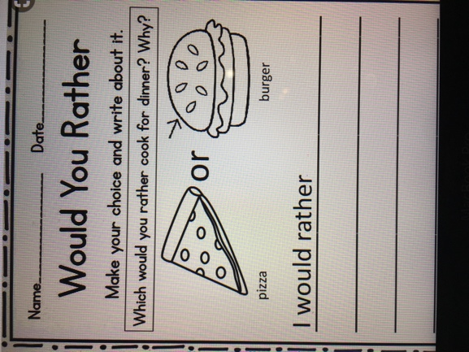
- For a creative center the students will have the opportunity to draw either their least favorite or favorite food on a piece of cardstock. So have paper and coloring supplies out for at least 5 students.

Then the teacher will introduce persuasive writing and sensory language and may ask
- Why might a writer use sensor language?
- How is this helper to the reader?
- What do we think will happen in “Tales for very picker eaters”?
- How do you think the main character feels towards certain foods?

During the lesson the teacher will begin by having everyone sit on the rug and introduce the theme of persuasive text and the use of sensory language. Then she will introduce new vocabulary that’s In the book

- Ranches: A large farm

- Disgusting: Arousing revulsion or strong indignation.

- Marathon: A long-distance running race

- Basement: Floor of a building partly or entirely below ground level

- Repulsive: Arousing intense distaste or disgust.

- Lumpy: Full of or covered with lumps

- T Rex & Tyrannosaurus: Type of dinosaur

Then will read the book aloud to the class while they are on the rug. Through out the reading she may ask

- From reading this page how did the writer describe how the little boy feels?
- How does the writer make us feel about these foods?

The teacher will have a mini lesson Reviewing persuasive text and how the author in the book used sensory language to persuade the reader and the little boy in the book. Then the students will have time to go write in their journals about their favorite and least favorite foods, explaining why they like or dislike the food. Students will begin practicing their persuasive texts. The teacher will make sure students understand they are persuading the reader to feel or believe a certain way about something. Then the students will share their thoughts within their small groups. After that the students will be given Ipads (one per group) and the each group will work together to write their own version of the story. Changing up the foods within the text and how they are described. Each group will share their story. Then the students will go back to their seats and continue practicing their own persuasive texts. Using their journal entry they will add sensory language and persuasive language to make a short writing. After The teacher will review sensory language if necessary. If they finished this during the first writing the will use this time to begin revising. The students will then break up into centers. Teacher going around to make sure all questions are answered and meeting with students whom need some extra help. Once centers have been done the teacher will end with a brain break song from go noodle.

Reflections and Documentation/Evidence of Lesson Effectiveness
I loved this book because it could be used in so many different content areas and could be used for a variety of different activities and themes. Children love creating their own stories and getting the opportunity to bring their ideas to life so I wanted to give them plenty of opportunities to do that. It also gives multiple opportunities to assess the student’s knowledge regarding vocabulary and understanding of the lesson.

