UNT Lesson Plan Template

Pre-service Teacher: | Grade(s):  2nd | School/Mentor Teacher (if applicable):
Subject area(s):  Reading/Writing | Unit Topic/Theme:  Be kind to everyone/the power of words | Lesson Title:  Read-aloud: Chrysanthemum
Find the TEKS, ELPS, and CCRS standards at this link:
http://www.teksresourcesystem.net/module/standards/Tools/Search
Relevant TEKS:  §110.13. English Language Arts and Reading, Grade 2, Beginning with School Year 2009-2010.  (3) Reading/Beginning Reading/Strategies. Students comprehend a variety of texts drawing on useful strategies as needed. Students are expected to:  (A) use ideas (e.g., illustrations, titles, topic sentences, key words, and foreshadowing) to make and confirm predictions;  (B) ask relevant questions, seek clarification, and locate facts and details about stories and other texts and support answers with evidence from text; and  (C) establish purpose for reading selected texts and monitor comprehension, making corrections and adjustments when that understanding breaks down (e.g., identifying clues, using background knowledge, generating questions, re-reading a portion aloud).  (9) Reading/Comprehension of Literary Text/Fiction. Students understand, make inferences and draw conclusions about the structure and elements of fiction and provide evidence from text to support their understanding. Students are expected to:  (B) describe main characters in works of fiction, including their traits, motivations, and feelings  (18) Writing/Literary Texts. Students write literary texts to express their ideas and feelings about real or imagined people, events, and ideas. Students are expected to:  (B) write short poems that convey sensory details | Relevant ELPS:  §74.4.C.2.C  learn new language structures, expressions, and basic and academic vocabulary heard during classroom instruction and interactions;  §74.4.C.2.G  understand the general meaning, main points, and important details of spoken language ranging from situations in which topics, language, and contexts are familiar to unfamiliar;  §74.4.C.3.E  share information in cooperative learning interactions;  §74.4.C.2.G  express opinions, ideas, and feelings ranging from communicating single words and short phrases to participating in extended discussions on a variety of social and grade-appropriate academic topics; | Relevant TX CCRS:  II. Reading B1  Understand new vocabulary and concepts and use them accurately in reading, speaking, and writing. Identify new words and concepts acquired through study of their relationships to other words and concepts.  III. Speaking B1,2  Develop effective speaking styles for both group and one-on-one situations. Participate actively and effectively in one-on-one oral communication situations. Participate actively and effectively in group discussions.
Lesson Objective(s)/Performance Outcomes
Objectives:
- What can we do when we are being made fun of?
- What skills did the main character learn by the end of the book that helped her accept her name?
- What can the students infer about what will happen next in the story?
- Can the reader restate the events in order of occurrence orally?
Performance Outcomes:
- Student will be able to make inferences about what will happen next in the story.
- Student will be able to identify vocabulary words from the book.
- Student will be able to explore the positive effects of kindness.
Assessment (Description/Criteria)
Formative- Teacher will ask questions before, during, and after to keep students engaged in the read-aloud. Teacher will pay attention to who is actively participating and direct questions towards those who are not. Give students a buddy to think-pair-share with. Have students make predictions, find main idea, over all message, identify main characters, sequence of events.

Teacher will collect poem and other assignments. He/she will also assess the different areas of literacy throughout the lesson. The teacher will walk around the classroom during the individual/small group activities to check for understanding and clarify any questions. This will show the teacher who is struggling and in what areas. Students will have access to the vocabulary words at the front of the classroom we learned before reading the story for reference.

Materials and Resources
Book:
- Chrysanthemum by Kevin Henkes
Activities:
- https://www.encourageplay.com/blog/chrysanthemum-wrinkled-heart-activity
- https://onesharpbunch.com/2016/08/name-activities-using-chrysanthemu.html

Websites:
- KidzSearch https://www.kidzsearch.com
- Kidtopia http://www.kidtopia.info
- KidRex http://kidrex.org
- Teach the Children Well http://www.teachthechildrenwell.com
- GoGooligans http://www.gogooligans.com
- KidsClick http://www.kidsclick.org

Other Materials:
- i-pad with access to Seesaw and camera
- Cut out hearts (one per student)
- Writing journals
- Pictures of vocabulary words for pre-reading
- Chrysanthemum plant
- Bag with various types of flowers
- Nametag for students to write the name of their chosen flower on
- Paper for the poem
- ELL vocab picture dictionary chart
- Pencils
- Construction paper
- Markers
- Decorating supplies-ribbon, glitter, crayon, stencils, stickers, stamps, beads, beans, macaroni, feathers, etc.
- Glue
- Large paper for class chart on front board
- Letter cut outs of every one’s name
- Baby name book

Management of the Instructional Environment
Assemble the students in the circle area and show the book, Chrysanthemum to them. Teacher will introduce the vocabulary words and show visuals of examples. Conduct a picture walk, allow students to guess what might happen in the story. Next, the teacher will read aloud the story. Students will go back to their desk and the teacher will introduce the activities one at a time. Each activity will end in a discussion.

Technology Integration
- Kid friendly search engines to research meaning of their name
- I-pad with access to camera and Seesaw to share a picture of themselves with a few sentences on the meaning of his/her name. Students will leave a positive comment on another peer’s post.

Diversity and Equity (Accommodations, Modifications, Adaptations)
For all students, the teacher will speak clearly and check for understanding before moving on. The teacher will state and write the objectives and goals for the students. For advanced students, if time permits, have them use the vocabulary words in a sentence and write them down in their writing journals. For students who are struggling, they can create a vocabulary chart to refer back through during the lesson. For ELLs, the teacher can give them a worksheet with the vocabulary word and its’ corresponding picture. Beginners can be paired up with an advanced or advanced high ELLs if available.

Activities/Procedures
Read:
- Read, Chrysanthemum by Kevin Henkes
Henkes, K. Chrysanthemum. NY: Harper Collins, 1991.

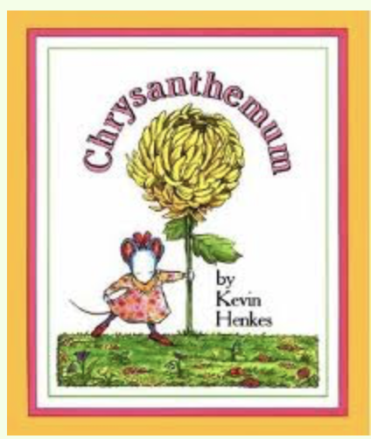
Discussion:
Before-
- Introduce vocabulary words and provide visual examples
- Jealous-afraid of losing someone’s love or attention to another person, envy of what another person has or can do
- Perfect- being complete of its kind and without defect or blemish
- Friendship- state or condition of being a friend
- Envy- a feeling of wanting what someone else has
- Kindness- the quality of being kind, a generous act or favor
- Dreadful- exceptionally bad or displeasing
- Wilt- to bend over and dry up
- Teasing- to make fun of or try to annoy in a playful or cruel way
- Mean- Not nice
- Chrysanthemum- a type of plant grown for its flowers that bloom in autumn. Some species are grown for a compound that kills insects on crop plants.
- Begrudge- to want what someone else has
- Indescribable- something that cannot be put into words
- Inform- to tell
- Precious- something is very special or valuable
- Scarcely- not much or just a little bit
- Talk with students about their first names. Ask: “What do you like about your name? Dislike?”, “Do you know why you were given this name? If so, what was the reason?”. “If you could have another name, what would it be? Why?”.
- Bring a chrysanthemum plant to show students. Let them come up to look at it closely. Ask them to think-pair-share. Think about how they would describe the flower, tell it to their pair, and share with the class.
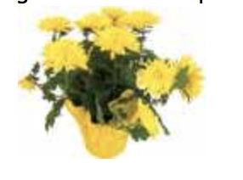
- Tell students we will be reading a story about a mouse named Chrysanthemum.
- Ask if they know of a person or animal that also has the name of a flower.
During-
- (Hand students a cut-out heart) Tell students that, as you read the story aloud, they should fold their hearts each time something mean is said to Chrysanthemum, or each time something is said that makes her feel sad. Tell students to unfold their hearts each time positive, nice things are said to Chrysanthemum.
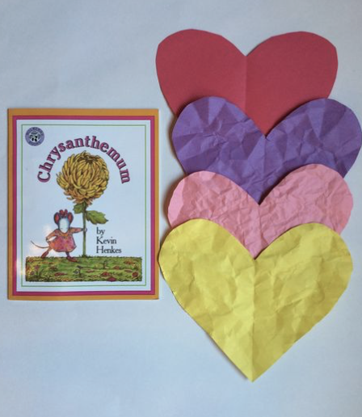
https://www.encourageplay.com/blog/chrysanthemum-wrinkled-heart-activity
- How did Chrysanthemum feel about her name in the beginning of the story? (She loved her name)
- Why would someone want to change his or her name? (Maybe they do not like it, or someone made fun of their name)
- Why do you think the class laughed when Mrs. Chud took attendance? (They thought her name was too long, funny)

- Would you have laughed at Chrysanthemum, even though it hurt her feelings? (various answers, open-ended question)
- What changed Chrysanthemum’s feelings about her name? Do you think she should feel badly about her name? What do you think should have done? (She was teased about her name, various answers, open-ended)

- What kinds of things did Chrysanthemum’s parents tell her to help her feel better about what was happening at school? (They told her they were probably jealous of her name)
- What could Chrysanthemum’s best friend do to help her to not feel sad about being teased? (various answers, open-ended)
After-
- When you finish the story, the students’ hearts should be unfolded. Direct the students to try to get all the wrinkles out of the hearts. Give them a few minutes to try to get them out. Then discuss how they cannot get all the wrinkles out. (We can forgive people for saying mean things and hurting our feelings, but they still leave an impression, or a wrinkle, on our hearts and feelings. The next time a student makes fun of another person you can remind him/her that he/she is causing that person to have a wrinkle, or impression on his/her heart).
- Ask students post reading questions: How do you think Chrysanthemum felt when students teased her? What would you have done if you were Chrysanthemum? How do you think Chrysanthemum felt when Miss Twinkle told the class how much she loved the name “Chrysanthemum?”. Is perfection possible? How do you know that? Do you think there can be a perfect characteristic about someone or a part of someone that is perfect? Have you ever been jealous of someone else? How did you treat the person you were jealous of? Do you think that Chrysanthemum’s mother was right, that the kids really were jealous and that is why they were being mean to her? How could Chrysanthemum have reacted in a different way? Would it have made a difference? What did we learn about other people’s differences in this story? What would you say to Chrysanthemum if you could?
- Tell your students we are going to have a “change your name day”. The teacher will walk around and students will pull one artificial flower from the bag with their eyes closed. Tell students that the name of the flower will be their name for the day. Students can keep their flower at their table or on their desk and wear a nametag with the flower name printed on it to remind classmates of their new name. For the remainder of the school day, students will refer to their peers by their flower names.
- Students will individually write a short poem and beginner/intermediate ELLs will work with an advanced/advanced high ELL to write the poem if available. Students will use the “If I Were” Pattern. Name the flower (one they pulled from the bag). Tell where it is found. Name two things it can do. Repeat the first line.
Example:
If I were a rose
In a beautiful garden
I would stretch myself out
And bring joy to someone’s day
If I were a rose
- At the end of the day, teacher will remind students of the way Chrysanthemum’s parents supported her throughout the story. Have students think about problems they may have had and the ways their parents/family were supportive or helped them resolve their problems. Encourage students to describe what it feels like to have the support and understanding of others. Later, students can think of ways they might be more helpful or supportive to someone else.
Math- Students can count the number of letters in their name. We can make a class graph using the number of letters in each student’s name. Students will brainstorm ideas and work together to title and label the graph. We find out whose name has the most letters and who has the fewest. We can find out how many letters are in all of our names together, sort our names into categories (vowel sounds, number of letters, number of syllables).
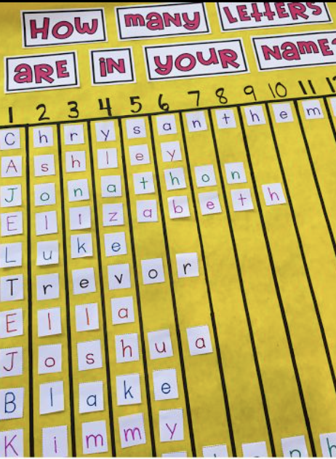
https://onesharpbunch.com/2016/08/name-activities-using-chrysanthemu.html

Art- Students will each receive a piece of construction paper and write their first name with a marker on the front. They will trace their name with glue. Then they will decorate their name with a variety of provided materials (sequins, beans, glitter, wrapping paper, stickers, ribbon, feathers, crayons, etc.) When students are finished, each student will show their peers their artwork. We will discuss how no one decorated their name exactly the same. We are all different and that is okay.
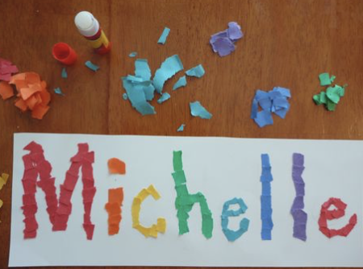

Group Activity: Students will use their i-pad to take a picture of themselves. They will use kid friendly search engines provided by the teacher to find out what his/her name means. On the class Seesaw account, students will post their picture to their portfolio with a few sentences about the meanings of their name and why they love their name. Students will respond with a positive comment to another peer’s post.
- KidzSearch
- Kidtopia
- KidRex
- Teach the Children
- GoGooligans
- KidsClick
- Teacher can also bring a baby name book

Reflections and Documentation/Evidence of Lesson Effectiveness
I think that the book Chrysanthemum is a great book to read at the beginning of the school year when students are entering a new classroom and building friendships. This book has a lot of great vocabulary words related to feelings, friendships, and bullying. I think students will be able to connect to Chrysanthemum and discuss ways that bullying could be resolved. This story has an amazing message of being kind to one another. It is vital for students to understand that words can hurt, so we should think before we speak. There are a lot of great activities that can be incorporated throughout this lesson plan for every subject. I think the story is a great way to discuss a serious topic to students. I would definitely use this in my own classroom.

