Pre-service Teacher: | Grade(s):  Kindergarten | School/Mentor Teacher (if applicable):
Subject area(s):  Reading and Language Arts | Unit Topic/Theme:  Read aloud | Lesson Title:  Read aloud with I Broke My Trunk
Find the TEKS, ELPS, and CCRS standards at this link:
http://www.teksresourcesystem.net/module/standards/Tools/Search
Relevant TEKS:  §110.11. English Language Arts and Reading, Kindergarten, Beginning with School Year 2009-2010.  (4) Reading/Beginning Reading/Strategies. Students comprehend a variety of texts drawing on useful  strategies as needed. Students are expected to:  (A) predict what might happen next in text based on the cover, title, and illustrations; and  (B) ask and respond to questions about texts read aloud.  (8) Reading/Comprehension of Literary Text/Fiction. Students understand, make inferences and draw  conclusions about the structure and elements of fiction and provide evidence from text to support  their understanding. Students are expected to:  - retell a main event from a story read aloud; | Relevant ELPS:  §74.4.D.2.B.i  are able to express simple, original messages, speak using sentences, and participate in short conversations and classroom interactions; may hesitate frequently and for long periods to think about how to communicate desired meaning. | Relevant TX CCRS:  II: Reading  A. Locate explicit textual information and draw  complex inferences, analyze, and evaluate  the information within and across  texts of varying lengths.  4. Draw and support complex inferences  from text to summarize, draw conclusions, and distinguish facts from simple assertions and opinions.  9. Identify and analyze the audience,  purpose, and message of an Informational  or persuasive text
Lesson Objective(s)/Performance Outcomes

Objectives:
Can the reader list the events in order of occurrence?
Can the reader understand the message of the story?
Can the reader make estimates on what will happen next in the story?
Performance Outcomes:
Students will be able to sequence the story from beginning to end.
Students will be able to explain the message of the story.
Student will be able to make inferences about what will happen next in the story.

Assessment (Description/Criteria)
Formative: Ask students’ discussion questions before, during, and after the story. Focus on prediction, sequencing and whether they can distinguish the message of the informative text. The teacher will keep record of who is actively participating and ask what and why questions to the ones that don’t.

Collect the children’s worksheets and projects will access the different areas of sequencing and understanding the meaning of the lesson. Collecting these items will show me who understands and doesn’t.

Materials and Resources
Book:
• I Broke My Trunk by Mo Willems
Activities:
- https://www.teachingbooks.net/media/pdf/DisneyHyperion/Elephant_Piggie.pdf
- http://pigeonpresents.com/teachersguides/EandP_eventkit2013.pdf
- https://www.islma.org/pdf/monarch/We%20Are%20in%20a%20Book%20web.pdf

Other Materials:

- Markers
- White Paper
- Pencils
- Ipads
- Glue
- Scissors
- Envelopes

Management of the Instructional Environment
- Students start off by being in circle time to read and discuss the book
- After the story, the teacher will pick from stick jar to place students in groups.
- Teacher will walk around the classroom to monitor the children during center time.
- After center time, the teacher will gather students for circle time to conclude the lesson.
Technology Integration
- Ipads to make their own story on “Story creator” application
- Allow students to write on smart board during discussion time.

Diversity and Equity (Accommodations, Modifications, Adaptations)
Provide the picture book for ELLs when doing the activities to see the visuals. Assist ELLs during the center time when needed and provide examples of activities.

Activities/Procedures (18 minutes)
Read:
- I Broke My Trunk! By: Mo Willems
Discussion:
Before:
- What does caring mean?
- What are some examples of being caring?
- What do you think the story is about?

During:
- How do you think Gerald broke his trunk?
- What do you think hippo did to Gerald’s trunk?
- Why do you think the words on this page are smaller than the other ones?
- What do you think happened to piggie?

After:
- Why do you think Gerald brought up all the plans he had before telling what really happened to his trunk?
- What would you guys do in Piggies situation, as a friend, to make elephant feel better?
- What happened in the story?

Centers:(18 minutes each center)
Literacy-
- Make a “long crazy” story- Students will have the chance to make their own stories on “story creation” app about something they routinely do and make it elaborate. The children would draw their story and share their stories in groups.

- Sequencing book worksheet- Children will tell the beginning, middle and end of the story by writing and drawing pictures.
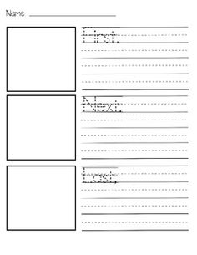
- Weight on Gerald’s Trunk- Have students sequence each of the objects as they cut and glue them on his trunk from first to last.
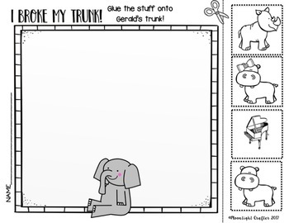

Art-
- Get well card letters: Have students color a card to give to children at a children’s hospital. The children will get to experience what caring for others feels like for people. Children might even get the opportunity of getting a letter back. The children would have the chance to share their letter with the class.
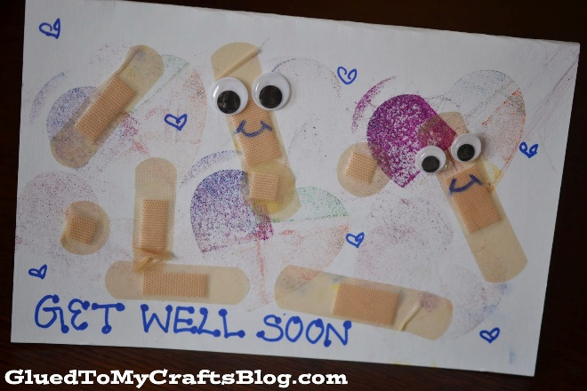

http://pigeonpresents.com/teachersguides/EandP_eventkit2013.pdf

Reflections and Documentation/Evidence of Lesson Effectiveness
I found many ways that you can integrate this book into different activities. My focus was to concentrate on sequencing and getting them to understand the meaning of the story. I found many great resources, but most of them just had to do with the language arts and reading area. Science, math and social studies was hard to find with relating to the story. This will be a great way to get children’s knowledge in sequencing and giving them a chance to be creative.

