UNT Lesson Plan
Pre-service Teacher:  H. Patino | Grade(s):  First Grade | School/Mentor Teacher (if applicable):
Subject area(s):  Language Arts  Phonemic awareness, rhyming, writing, reading comprehension | Unit Topic/Theme:  Rhyming | Lesson Title:  Robot Rhymes
Relevant TEKS:  §110.12  (B) Knowledge and skills.  (2) Reading/Beginning Reading Skills/Phonological Awareness. Students display phonological awareness. Students are expected to:  (A) orally generate a series of original rhyming words using a variety of phonograms (e.g., -ake, -ant, -ain) and consonant blends (e.g., bl, st, tr); | Relevant ELPS:  §74.4.  (D)Proficiency level descriptors.  (1) Listening, Kindergarten-Grade 12. ELLs may be at the beginning, intermediate, advanced, or advanced high stage of English language acquisition in listening. The following proficiency level descriptors for listening are sufficient to describe the overall English language proficiency levels of ELLs in this language domain in order to linguistically accommodate their instruction.  (B) Intermediate. Intermediate ELLs have the ability to understand simple, high-frequency spoken English used in routine academic and social settings. These students:  (i) usually understand simple or routine directions, as well as short, simple conversations and short, simple discussions on familiar topics; when topics are unfamiliar, require extensive linguistic supports and adaptations such as visuals, slower speech and other verbal cues, simplified language, gestures, and preteaching to preview or build topic-related vocabulary; | Relevant TX CCRS:  Listening B.1  Listen critically and respond appropriately to presentations.  Speaking B.2  Participate actively and effectively in group discussions.
Lesson Objective(s)/Performance Outcomes
Objectives:
- How can I make words rhyme?
- What is a rhyming word?
- How do I know when words rhyme?
- Why do words rhyme?

Performance Outcomes:
Upon completing this lesson, students will:
- Be able to recognize rhyming words/ pictures.
- Identify that rhyming words have the same ending sound.
Assessment (Description/Criteria)
Formative Techniques:
During the “Rhyming Detective” activity, the teacher will assess the students by listening to the examples of rhyming words they provide during the activity. To assist student, the teacher will remind the students that rhyming words have the same ending sound. As the students recognize rhyming words by placing a finger on their nose when reading the book aloud, the teacher then asks the student to state the words and compare if they rhyme or not. During this process the teacher will keep track of the students understanding by having a log to document when the student correctly identifies rhyming words.

During the “Rhyming Partner Hunt” activity, the teacher will assess the students by their ability to provide an example of a rhyming word. Each student will receive a card with different words and will be asked to come up with a word that rhymes with the word they were provided. This will give the teacher and understanding in how well the students comprehend rhyming words by recognizing the sounds and providing examples.

Materials and Resources
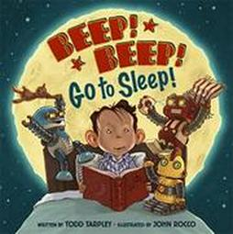
- Book-Beep! Beep! Go to Sleep, by Todd Tarpley
- Ipad/Computer-as an option to read aloud
- Rhyming Robot match cutout cards
- Rhyming Partner Hunt cards

Management of the Instructional Environment
Rhyming Detectives: This activity will be conducted as a whole group as we gather to read the book in our open spaced rug. As detectives there are no materials, but the students have to listen carefully to find rhyming words.

Rhyming Robot Match: This activity will be conducted in groups of 2-3. The students will be directed to go back to their tables and the teacher will group the students accordingly. The teacher will then handout Rhyming Robots and the activity would begin.

Rhyming Partner Hunt: This activity will be conducted individually. The students will be asked to come back to the rug and can either sit or stand in a circle. The teacher will walk around with a box asking the children to pull out a card with different words, then the activity would begin.
Technology Integration
In the Rhyming Partner Hunt activity, the teacher will use the computer to display corresponding pictures to the words that the children pull from on the board. The teacher would need to have this prepared in advance to make sure activity is done properly.
This lesson could also incorporate the use of Ipads. The Ipad can be used as a technological tool to aid the read aloud.
Diversity and Equity (Accommodations, Modifications, Adaptations)
Accommodations: For students that are struggling, the teacher should have words broken down into syllables on the word cards. The teacher should review with the students that rhyming words have the same ending sound and provide more examples to help students comprehend.
Modifications: For advanced learners, the teacher should have challenging vocabulary words prepared or have the students work independently during the “Rhyming Robot Match” activity. The teacher could also challenge the students by having them identify the syllable that makes the matching words rhyme.
Adaptations: To assist English language learners I would have the vocabulary words translated in their native language and would also include pictures on the cards to help them with the activity.
Activities/Procedures
Before: Intro /Rhyming Detectives
- Gather the class for the start of the lesson at the reading rug. Ask students if they are familiar with rhyming words. The teacher will introduce the topic rhyming words by explaining that they are words have the same ending sound and by providing examples.
- Use Ipad or book to read aloud Book-Beep! Beep! Go to Sleep. Before reading the book, have the students mention any predictions they have over the story. After reading the book aloud once, ask students if they head any words that rhymed in the story.
- Begin reading the story a second time and explain to the students that they are going to be “Rhyming detectives” and must touch their nose when they hear any words that rhyme. Whenever students touch their nose, stop reading and ask the students to state the words and compare them. Remind the students that rhyming words have the same ending sound and that there are many of them throughout the book. This will help assess the students understanding of rhyming words. To help students the teacher should pause at the end of rhyming stanzas so the students can focus on the vocabulary before moving on.
During: Rhyming Robot Match
- Once the class finishes reading the story a second time, have them go back to their seats. The teacher will then place the students in small groups of 2-3 and hand each group three sets of rhyming robot matching cards.
- Encourage students to say what each picture is and to work together to correctly find the matching card that rhymes.
- This activity will help students collaborate and learn with classmates how to identify words that rhyme.
- The teacher should walk around and recognize any correct matches and also help students that may need assistance by hinting to complete one puzzle set by color at a time.
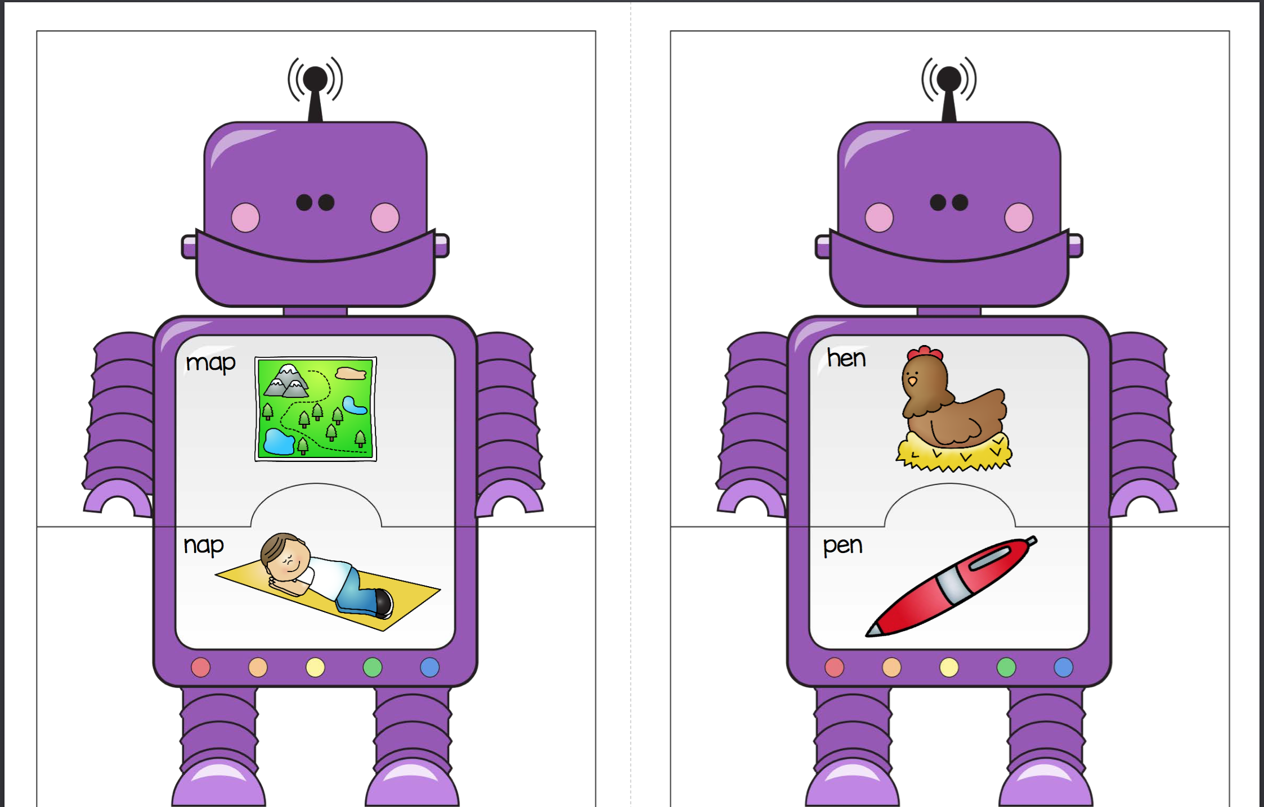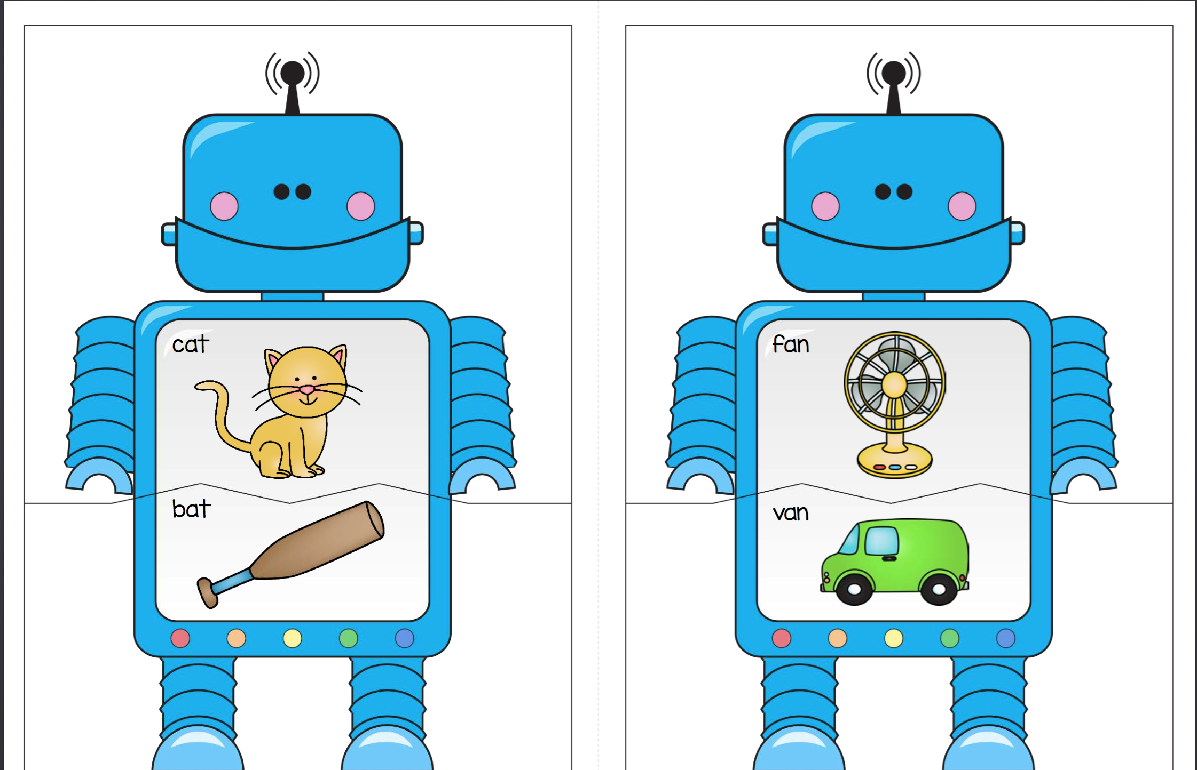
Reference included on bottom*

After: Rhyming Partner Hunt
- After completing the rhyming robot match activity, gather the class back on the reading rug. Review with the students what rhyming words are by asking them what they have learned and if they can provide examples.
- Have each student pull out one card from the mystery box.
- The students will then take turns naming the card they pulled and attempt to come up with a word that rhymes with the word they have.
- The teacher will then use the computer to display on the screen pictures of the corresponding words the students have. This needs to be prepared ahead of time.
- Inform the students that they all have one partner that has a word that rhymes with the one they have and they need to “hunt” for them.
- If students are struggling, the teacher should help the student by giving them guidance and also having students look on the board to find a picture that would rhyme with their word.
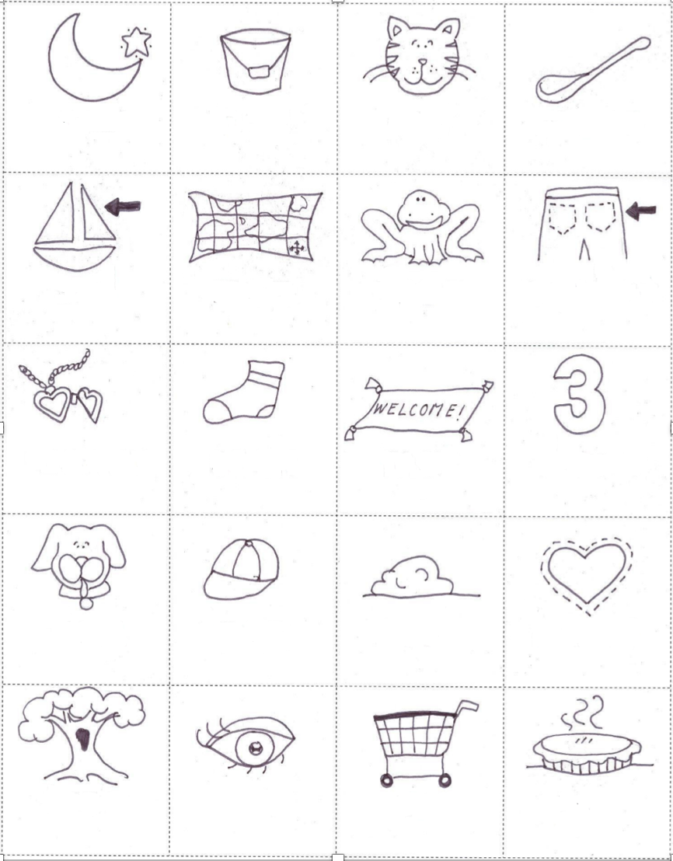
Reflections and Documentation/Evidence of Lesson Effectiveness
I believe this lesson accommodates for all types of interaction and learning opportunities for the students. One thing I would adjust as I go through my lesson would be during the “Rhyming Partner Hunt” activity. During this activity if I notice any students that have been struggling the whole lesson I wouldn't want them to feel as if they were put “on the spot” to come up with a rhyming word so I would adjust it to have the students only pronounce their word. Besides this adjustment I believe I have incorporated effective group and individual activities the students would be able to learn from.

References

Gorden, B. (1970, January 01). 123 Homeschool 4 Me. Retrieved September 28, 2017, from http://www.123homeschool4me.com/

