UNT Lesson Plan #1
Pre-service Teacher: | Grade(s): 2nd | School/Mentor Teacher (if applicable): Dr. Eutsler
Subject area(s):  Language Arts and Reading  Thinking and Reasoning  Social Studies | Unit Topic/Theme:  Phonemic Awareness and making Cultural Connections | Lesson Title:  Christmas on The Polar Express
Relevant TEKS:  §110.4. English Language Arts and Reading, Grade 2, Adopted 2017  (1) Developing and sustaining foundational language skills: listening, speaking, discussion, and thinking--oral language. The student develops oral language through listening, speaking, and discussion. The student is expected to:  (A) listen actively, ask relevant questions to clarify information, and answer questions using multi-word responses;  (B) follow, restate, and give oral instructions that involve a short, related sequence of actions;  (7) Response skills: listening, speaking, reading, writing, and thinking using multiple texts. The student responds to an increasingly challenging variety of sources that are read, heard, or viewed. The student is expected to:  (D) retell and paraphrase texts in ways that maintain meaning and logical order;  (E) interact with sources in meaningful ways such as illustrating or writing;  (13) Inquiry and research: listening, speaking, reading, writing, and thinking using multiple texts. The student engages in both short-term and sustained recursive inquiry processes for a variety of purposes. The student is expected to:  (C) identify and gather relevant sources and information to answer the questions; | Relevant ELPS: (Texas English Language Proficiency Standards)  §74.4.D.4.A.v  (v) are highly dependent on visuals and prior knowledge to derive meaning from text in English; and  §74.4.D.4.B.vi  (vi) are able to apply basic and some higher-order comprehension skills when reading texts that are linguistically accommodated and/or simplified for this level. | Relevant TX CCRS:  II. Reading  A. Locate explicit textual information, draw complex inferences, and analyze and evaluate the information within and across texts of varying lengths.  3. Identify explicit and implicit textual information including main ideas and author’s purpose.  4. Draw and support complex inferences from text to summarize, draw conclusions, and distinguish facts from simple assertions and opinions  B. Understand new vocabulary and concepts and use them accurately in reading, speaking, and writing.  2. Apply knowledge of roots and affixes to infer the meanings of new words  V. Research  1. Formulate research questions.  2. Explore a research topic
Lesson Objective(s)/Performance Outcomes
Objectives:
- How does sequencing the events of a story help the reader understand the main idea of the story?
- What can the students infer about the meaning and purpose of the story through discussion?
- Can the reader list the events in order of sequence and retell the story?
- Can the students research and formulate ideas of Christmas across different cultures?
- Can the students recognize compound words, and how do these words expand their vocabulary?
- How does recognizing syllables influence a student’s understanding of phonics?

Performance Outcomes: Learning Goals (see Lesson Plan: Essential Qs vs. Learning Goals on BB Content)
- Students will be able to read a list of words and come up with new compound words.
- Students will be able to sort words based on the number of syllables they have.
- Students will be able to sequence the events of The Polar Express from beginning to end.
- Students will be able to make inferences and discuss the main idea and purpose of the story during the read-aloud.
- Students will be able to research on their own using iPads and come up with differences in the celebration of Christmas across cultures. (ex: different holiday figures such as Santa)

Assessment (Description/Criteria)
Formative technique(s): Ask students’ discussion questions before, during and after the story. Focus on new vocabulary, compound words, and ask deeper questions about the implicit meaning and purpose of the book. Record who is actively participating and direct questions towards those who are not, making sure everyone contributes to classroom discussion, especially ELL students.
Summative technique(s): Keep a checklist of each student and check whether they have completed the assignments in each center. Collect the written literacy assignments, culture assignment, and writing prompt. Assess the different areas focusing heavily on the syllables and compound word assignments. This will show areas that you need to go over again or teach a different way.

Materials and Resources
Particular book title, name(s) of handout(s) (attached to the lesson plan), craft supplies, specific technology, website(s), application(s)

Book:
The Polar Express, by Chris Van Allsburg

Activities/Helpful Websites:
http://www.bookitprogram.com/redzone/readanddo/top25/ThePolarExpress.ai.pdf
http://www.busyteacherscafe.com/literature_guides/polarexpress.html
https://www.scholastic.com/teachers/lesson-plans/teaching-content/polar-express-lesson-plan/
http://homesweetspeechroom.blogspot.com/2012/12/polar-express-phonological-awareness.html

Other materials:
- Computer
- iPad
- Craft Supplies ie. (construction paper, markers, googly eyes, etc.)

Management of the Instructional

Two class periods are ideal but the lesson can be completed in a period of 90 minutes as well. Students start off in circle time while we read the story. In this part, we can include holiday favorites such as hot cocoa while we read the cozy story. (Approx. time: 30 minutes) When finished with the story the teacher will put the children into groups and begin centers after explaining each one thoroughly. When finished with centers teacher will collect the assignments from each center, transition the students back into the circle, and begin the group discussion over the different centers focusing on the culture assignment “Santas Around the World”, and have the children share what they found. (15 minutes at each of the 4 stations if only 90-minute block is allotted) At the end I will ask the students to reflect on what they liked, what they think went well, and what they might change for next time.

Technology Integration

Computer or preferably iPads for the students to research how cultures around the world celebrate Christmas differently, focusing on the different figures such as Santa. If there are many iPads available, students can also document their progress at each station using the app Socrative.

Diversity and Equity (Accommodations, Modifications, Adaptations)
Describe your learners (think about your observation classrooms): # of ELLs, Gifted, IEP’s or 504s, behavioral plans, etc. What will you do to adapt this particular lesson to address EACH of these groups of students?

- Pre-teach difficult vocabulary and concepts of the book emphasizes including the “rare” words in the activity section.
- Pause and check for understanding before moving onto next page. Encourage the ELL students to be a part of the discussions when reading. If they are not orally responsive, encourage written response on white board.
- Assist ELLs during center time when needed.
- Speak slowly and clearly and show the visuals depicted in the book.
- When discussing syllables, it will be important to use techniques such as clapping along so the students can follow.
The centers are of mixed difficulties. This is on purpose so that the centers will be achievable regardless of the type of student they are. However, it will also push the boundaries of some students and with my help and the help of peers, we can scaffold their learning and ensure they are successful. I can easily make accommodations during the lesson if I see that the students are having a hard time with a task, or if it is too easy.

Activities/Procedures
Read:
- Read The Polar Express by Chris Van Allsburg

Discussion:
Before:
- Introduce the book and tell the children a little bit about it. Follow up with an interesting comment such as: “Have you ever been on a train before?” “Did you know this book takes place in the North Pole, which is the North-most point of the Earth?” or “I wonder what this train has to do with the story, let’s find out”. Here is a good time to introduce a few of the new vocabulary words and pre-teach them.
During:
- Discuss rare words as they come along and their definitions. Some examples of rare vocabulary words in this book include: rustle, conductor, aboard, nougat, and barren. These words may be unfamiliar to the students, especially ELL’s, so it is important to go over them.
- Questions to ask when reading: “What do you think the boy will discover on the train?” “Why do you think the boy and his sister can hear the bell but his parents can’t?” “What was the gift that Santa gave the boy?”
- This is also a good time to stop when you see a compound word and count the syllables together as a class by clapping.
After:
- “What do you think the bell represents?”
- “How do you think the boy felt when he realized he lost the bell?”
- “The boy's friend told him that Santa doesn't exist, but the boy continues to believe. Think of a time in your own life that you have experienced a situation where someone said you were wrong? How did it make you feel?”
- Discuss the purpose of the story.
- “Not everyone celebrates Christmas in the same way as the United States or at all. Do you know how other cultures may celebrate this holiday or a different one?”

Before moving on to the centers, it is important to go back over syllables and practice clapping with the students while saying a word so they can decipher how many syllables a word has. It will also be important to remind them of compound words and point out some examples that were in the book.

Centers:

Literacy: Syllable Sorting Train

- In this activity, students will draw conductor cards, count the syllables, and then place the card on the appropriate spot on the syllable sorting train (1, 2, 3 syllables).
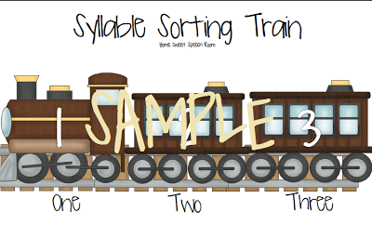
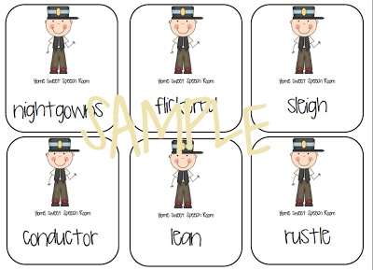

AND: Compound Trains:
- In this activity, the students will have a list of words like the ones in the picture below, and will have to write down “compound trains” or compound words that they find when they put the cards together. Students will be encouraged to come up with 6-8 from the deck of cards. EXAMPLE OF A FEW WORDS:
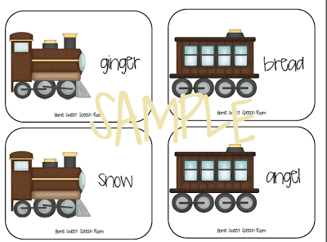

BOTH: http://homesweetspeechroom.blogspot.com/2012/12/polar-express-phonological-awareness.html

Social Studies/Technology Integration: Santas Around the World
- Some children in this country believe in Santa Claus if they celebrate Christmas. In other countries or cultures, children believe in other figures. Have the students research “Santa Clauses” around the world using iPads and briefly write down and share their findings with their group members.
http://www.busyteacherscafe.com/literature_guides/polarexpress.html
Art: Building your own Conductor
- In this center, set up supplies so that the children can make themselves into a conductor. They can be creative with this center and incorporate knowledge about conductors from the book to make their own. These can be hung up around the classroom.
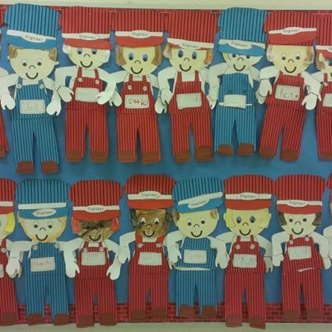
http://www.busyteacherscafe.com/literature_guides/polarexpress.html
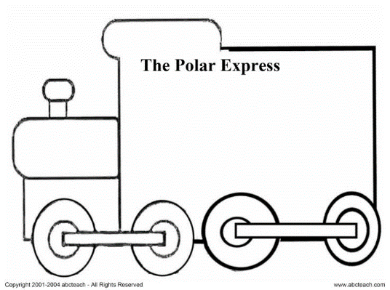
Writing: Sequencing Events
- Have the students write a “News Article” of The Polar Express, sequencing the events in the order they happened. The student will have to pick out a few main ideas of the story and focus on these in the paragraph they are allotted. This will help the students remember what happened in the story, as well as recognize the main ideas, and communicate this using new language and words from the story.

Reflections and Documentation/Evidence of Lesson Effectiveness

There are so many ways to incorporate this Christmas classic in the classroom. These are a few of the ideas I decided to share because I found that they were appropriate for the grade level I intend to teach. These activities will help the students learn new vocabulary, recognize compound words, count syllables, learn about other cultures, and most importantly, have fun. I would only do this lesson if a clear majority of my students celebrate Christmas, and I would still emphasize that there are other holidays and not everyone celebrates in the same way. Taking pieces from different resources allowed me to create a full-bodied lesson that encourages educating the whole student. Literacy and writing are used as well as a social studies and art integration. This allows students of all interests to better comprehend the material and further extend on their learning. The students will walk away with a better understanding of phonics after this lesson.

