UNT Lesson Plan Template
Pre-service Teacher: | Grade(s): 2nd grade | School/Mentor Teacher (if applicable):
Subject area(s):  Reading and Health Education | Unit Topic/Theme: | Lesson Title: Sticks Hurt, Stones Hurt, Words Hurt, EVERYTHING HURTS!
Relevant TEKS:  110.13(b)(9)(B)  Students understand, make inferences and draw conclusions about the structure and elements of fiction and provide evidence from text to support their understanding. Students are expected to: describe main characters in works of fiction, including their traits, motivations, and feelings.  115.4(b)(10)(D)  The student understands healthy and appropriate ways to communicate consideration and respect for self, family, friends, and others. The student is expected to: describe how to effectively respond to bullying of oneself or others. | Relevant ELPS: (CH 74.4)  74.4(c)(1)(F)  Cross-curricular second language acquisition/learning strategies. The ELL uses language learning strategies to develop an awareness of his or her own learning processes in all content areas. In order for the ELL to meet grade-level learning expectations across the foundation and enrichment curriculum, all instruction delivered in English must be linguistically accommodated (communicated, sequenced, and scaffolded) commensurate with the student's level of English language proficiency. The student is expected to: use accessible language and learn new and essential language in the process. | Relevant TX CCRS: TX CCRS  II(B)(1)  Identify new words and concepts acquired through study of their relationships to other words and concepts.
Lesson Objective(s)/Performance Outcomes
Essential Question: How do you think Chrysanthemum felt at different parts of the story?

Performance Outcomes/Learning Goals: Students will be able to describe and write about the feelings of the main characters of a work of fiction.
Assessment (Description/Criteria)
Formative technique(s): Visual Representation and Discussion
Written product with a checklist
Provide a rationale
For the formative assessment, I would like to use a visual representation and discussion, because the discussion would be a good way to make sure that they understood the book and the visual representation would be a good way to assess the visual learners over what they know.
For the writing assessment, I was going to have the students create a written product and have a checklist to make sure that each student learned something from the lesson and included all of the required components in their finished product.

Materials and Resources

Chrysanthemum by: Kevin Henkes
Hearts cut out of construction paper
Picture of Chrysanthemum
Colored construction paper cut into shapes of stems and leaves
Crayons
Pencils
Glue sticks
Scissors
Construction paper
Printout that says “Chrysanthemum is ______________. I know this because ______________________.”(example on attached page)

Seesaw app/website

Management of the Instructional Environment
This lesson will start out with the whole group but then move to individual work by the final activity. Students will be seated in groups for easy distribution of supplies though.
Technology Integration
Technology will be incorporated into this lesson by using the seesaw app to post a picture of each student’s assignment so everyone can see what each person did for the assignment.

Diversity and Equity (Accommodations, Modifications, Adaptations)
What will you do to adapt this particular lesson to address EACH of these groups of students?
Since Chrysanthemum has some long and possibly challenging words for 2nd graders, I will pre-teach the vocabulary words included in this book that my students probably wouldn’t quite understand yet.
Some examples of vocabulary words would be scarcely, dreadful, envious, discontented, and winsome.

Activities/Procedures
Before: First, the teacher will call the students to sit on the carpet for the lesson. The teacher will introduce the book Chrysanthemum by: Kevin Henkes to the class. After introducing the book, the teacher will tell the students that they will be listening for ideas of adjectives or words that describe Chrysanthemum in the story. The teacher will, also, give each student a construction paper heart, ask them to write their names on it, and explain that each time the bully says something mean to Chrysanthemum they will crush up their heart. Then, the teacher will tell them to try to flatten their heart each time Chrysanthemum felt a bit happier. After the explanations, the teacher will read Chrysanthemum to the students. After reading the book, the teacher will ask the students to try to flatten out their hearts. The teacher will then go on to explain that no matter how hard they try to make the heart look just like new, they can’t. The teacher will explain that that shows the effects that words can have on people, so we need to speak nicely and respect each other.
During: The teacher will, then, put a picture of Chrysanthemum on the board and ask the students to raise their hands and give words that describe Chrysanthemum in the book. The teacher will write the words that the students say on the board around the picture.
After: After working as a class, the teacher will send the students back to their seats and give them each a printout with wording that says “Chrysanthemum is ______________. I know this because ______________________.” After they finish writing the necessary information on the printout, they will cut and glue that printout onto a piece of construction paper that the teacher gives them. The teacher will then give each student another piece of construction paper for cutting out flower petals and a cutout of a stem and leaves. As the students finish their project, the teacher will take a picture of each one and post them on seesaw, so all students can see each other’s posts.
Use some teacher talk within all of these stages of learning.
Reflections and Documentation/Evidence of Lesson Effectiveness
Reflect on the process of writing the plan and what you might do differently to improve the lesson in the future.

As I wrote this lesson plan, I thought about this being a great lesson for near the beginning of the school year, because Chrysanthemum is a great book for teaching kids about how to respect each other.

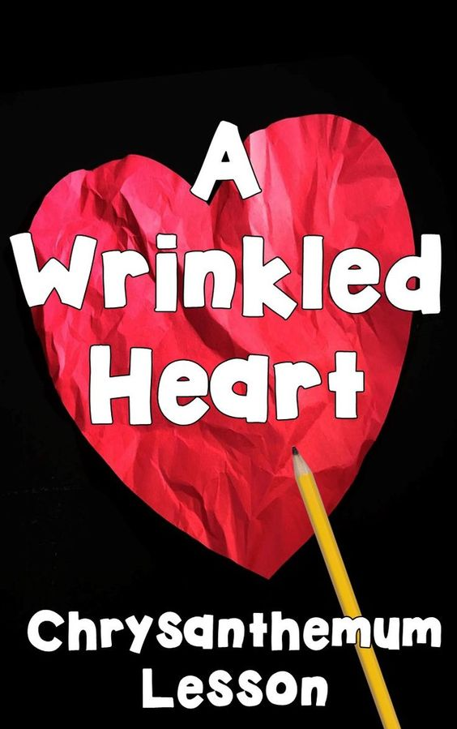
Pinterest links and images

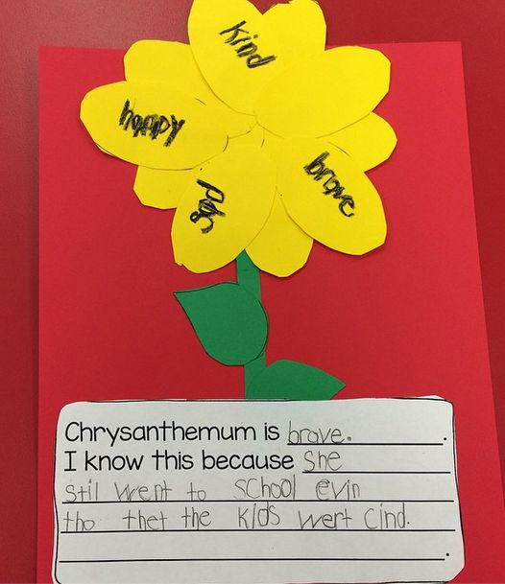
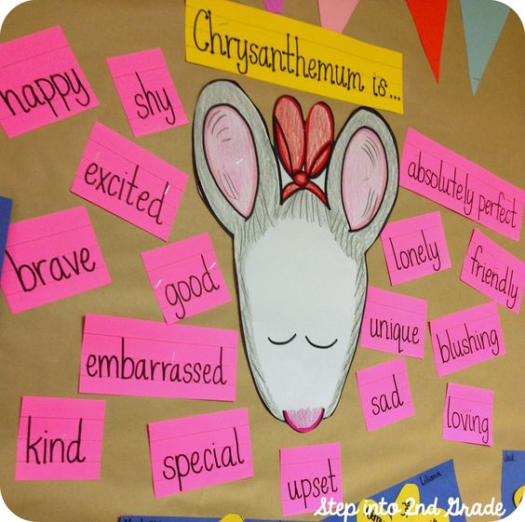
Chrysanthemum is… activity
https://www.pinterest.com/pin/371617406744787350/sent/?sfo=1&sender=371617544160707823&invite_code=58dfd570a90944b4b07d06c4b7b3bc79

Chrysanthemum is… writing activity
https://www.pinterest.com/pin/371617406744811221/sent/?sfo=1&sender=371617544160707823&invite_code=924c7834117c439f989f2d0d027f9b37

Wrinkled Heart lesson activity
https://www.pinterest.com/pin/371617406744787393/sent/?sfo=1&sender=371617544160707823&invite_code=1cb4e694b6804f89ac50eeef47e8c610

