UNT Lesson Plan Template
Pre-service Teacher: | Grade(s):  1st | School/Mentor Teacher (if applicable):  Dr. Eutsler
Subject area(s):  Language Arts and Reading/Writing  Math and Addition | Unit Topic/Theme:  Phonics  Consonant Digraph Sounds | Lesson Title:  Consonant Digraph Sounds with The Watermelon Seed
Find the TEKS, ELPS, and CCRS standards at this link:
http://www.teksresourcesystem.net/module/standards/Tools/Search
Relevant TEKS:  §110.12. English Language Arts and Reading, Grade 1, Beginning with School Year 2009-2010.  (3) Reading/Beginning Reading Skills/Phonics. Students use the relationships between letters and sounds, spelling patterns, and morphological analysis to decode written English. Students will continue to apply earlier standards with greater depth in increasingly more complex texts. Students are expected to:  (A) decode words in context and in isolation by applying common letter-sound correspondences, including:  (iv) consonant digraphs including ch, tch, sh, th=as in thing, wh, ng, ck, kn, -dge, and ph;  (9) Reading/Comprehension of Literary Text/Fiction. Students understand, make inferences and draw conclusions about the structure and elements of fiction and provide evidence from text to support their understanding. Students are expected to:  (B) describe characters in a story and the reasons for their actions and feelings.  §111.3. Mathematics, Grade 1, Adopted 2012.  (3) Number and operations. The student applies mathematical process standards to develop and use strategies for whole number addition and subtraction computations in order to solve problems. The student is expected to:  (F) generate and solve problem situations when given a number sentence involving addition or subtraction of numbers within 20. | Relevant ELPS:  §74.4.D.3.C.i  demonstrate comprehension of most main points and most supporting ideas in grade-appropriate stories read aloud in English, although they may still depend on visual and linguistic supports to gain or confirm meaning;  §74.4.D.5.C.ii  can participate meaningfully, with second language acquisition support, in most grade-appropriate shared writing activities using the English language; | Relevant TX CCRS:  English/Language Arts Standards  II. Reading  A. Locate explicit textual information, draw complex inferences, and analyze and evaluate the information within and across texts of varying lengths.  1. Use effective reading strategies to determine a written work’s purpose and intended audience  4. Draw and support complex inferences from text to summarize, draw conclusions, and distinguish facts from simple assertions and opinions.  Mathematics Standards  I. Numeric Reasoning  B. Number operations  1. Perform computations with real and complex numbers.
Lesson Objective(s)/Performance Outcomes
Objectives:
How does learning to use consonant digraphs help with new vocabulary and pronunciation?
In what ways do characteristics and features within texts and genres help a reader understand a writer’s intended meaning?
Why do we represent numbers in different ways?

Performance Outcomes:
Student will be able to pronounce the consonant digraphs “ch,” “sh,” and “th,” and use them in a word.
Student will be able to make predictions on what will happen next in the story.
Student will be able to solve a simple addition problem.

Assessment (Description/Criteria)
Formative: Ask the students discussion questions before, during, and after reading time. Focus on making predictions, character analyzation, pronunciation of consonant digraph in “chomp,” and thinking of additional sounds that could be used. Teacher should keep track of students who are actively participating and listening; ask specific questions to students who will not participate on their own.

Collect watermelon digraph worksheets and watermelon math projects to assess knowledge of consonant digraphs and addition/counting skills. Assess the student’s success on these assignments to determine whether or not they have mastered the concepts. Take note of what is done incorrectly for future lessons and assessments.

Materials and Resources
Book:
- The Watermelon Seed by Greg Pizzoli
Activities:
- http://www.applesandabcs.com/2016/04/watermelon-seed-addition.html
- https://www.kizphonics.com/phonics/digraph-ch-phonics-game/
- http://planningplaytime.com/2016/04/first-grade-worksheets-spring.html (digraph worksheet)
Other Materials:
- 4 Ipads (more if able), anchor chart, and markers.

Management of the Instructional Environment
Students begin with whole group time on the floor while the story is read (20 minutes).
Students will remain in whole group time while the teacher presents her/his mini lecture on digraphs (10 minutes).
Once finished with the story, students will be broken up into three equal groups and will rotate between three centers (60 minutes- 20 minutes per station).

Technology Integration
IPads will be used to access the application “Kiz Phonics 1st Grade1 Lite,” where students will play games that assess their knowledge of digraphs, specifically “ch, sh, th, wh, and ph.”

Diversity and Equity (Accommodations, Modifications, Adaptations)
Assist ELL students by clarifying unfamiliar vocabulary within the book, using pictures when necessary, also assist during center time when necessary. If students are struggling to grasp the concept of digraphs, take them back to the anchor chart and re-explain what was discussed in the mini-lecture. If students are excelling at digraphs, allow them to play an additional Kiz Phonics game on vowel digraphs.

Activities/Procedures
Read:
- The Watermelon Seed by Greg Pizzoli
Discussion:
Before-
- Why do you think this book is called The Watermelon Seed?
- What do you think this book will be about based on the title and front cover? Why do you think that?
During-
- What are other sounds besides “chomp” do you think a watermelon makes when you eat it? What about when you cut a watermelon?
- Why do you think the crocodile is worried that he swallowed the watermelon seed?
- How do you think the book will end?
After-
- What do you think would happen if you swallowed a watermelon seed?
- What message is the author, Greg Pizzoli, trying to tell us as readers?

Mini-Lecture:
Remind the students how much the word “chomp” was used in this story. Introduce the word “digraph” and explain/write down its definition on an anchor chart. Have the students identify the digraph within “chomp.” Have students think of other digraphs and write them down on the anchor chart, then come up with words that use them, letting students write them down if they are correct.
Example: “Alright class! Now that we have read The Watermelon Seed, could someone remind me of the word the crocodile used when he bites into the watermelon? Chomp? Correct! Well, the “ch” (sound it out) in chomp is actually known as a digraph. Everyone say that word with me, “digraph.” A digraph is a combination of two letters representing one sound. Other digraphs include “sh” as in shirt, “th” as in thing, and “wh” as in when.”

Centers:
Literacy-
- Watermelon Digraphs worksheet: children say the words in the pictures, find which digraph is used in each word, and color the words the correct color.
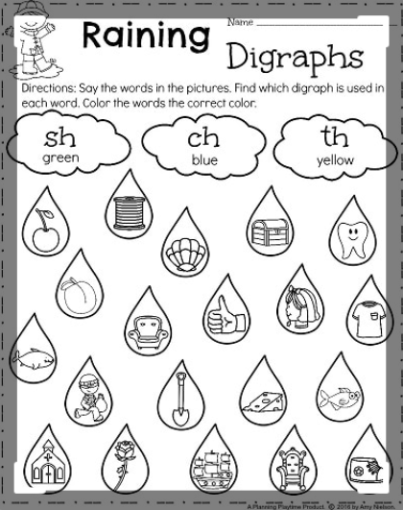
http://planningplaytime.com/2016/04/first-grade-worksheets-spring.html
**The “Raining” would be placed with “Watermelon,” the clouds would be watermelon slices, and the raindrops would be watermelon seeds.

- Diagraph IPad Application activity: “Kiz Phonics 1st Grade1 Lite.” Students will start with “ch” sounds, then will move on to the other digraph sounds within the app. Students can work in pairs, depending on the number of IPads available.
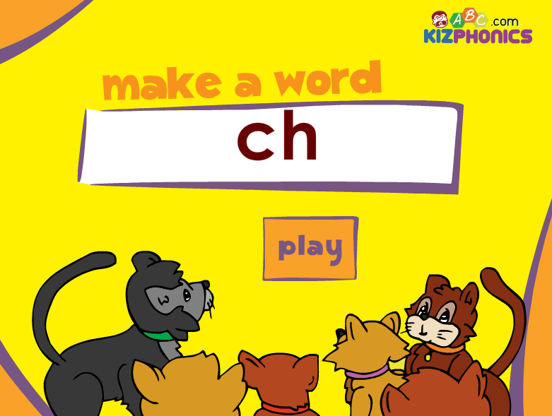
https://www.kizphonics.com/phonics/digraph-ch-phonics-game/

Math- Watermelon Seed Addition. Students will solve an addition problem by counting up the total number of watermelon seeds on the paper (given to them by the teacher) and will write the numbers in the blanks provided. Students will create a watermelon slice with pink paper, green paper, and black paint, and will cut and paste their problem in the flap of the watermelon slice.
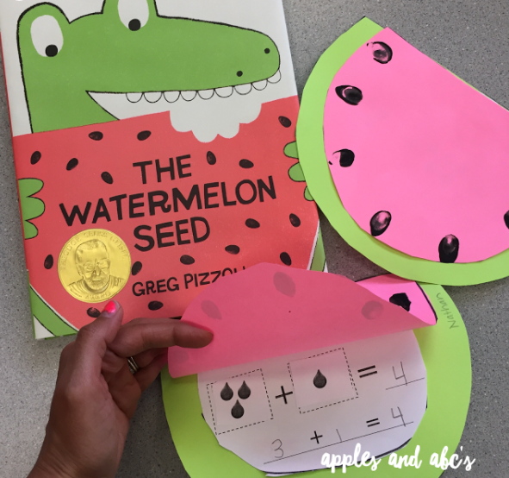
http://www.applesandabcs.com/2016/04/watermelon-seed-addition.html

Reflections and Documentation/Evidence of Lesson Effectiveness
While writing this lesson, I thought I did a good job incorporating activities that stuck to the topics the book covers. The majority of my time was spent finding appropriate standards, but the most fun part was finding activities. While writing the plan, I started off with too many ideas and overwhelmed myself. I am pleased with the lesson plan I created, but I would change the way I wrote it in the future. For example, I would start with just one idea and expand on it, rather than thinking of too many ideas and narrowing it down.
This book could be used to teach a variety of lessons. While my lesson focused particularly on consonant digraphs, a teacher could also create a lesson on onomatopoeias, as they are used all throughout the book. A teacher could also create a lesson where students write a short story on what would happen/what they would do if they swallowed a watermelon seed. I also incorporated math into my lesson, but teachers could easily incorporate a science lesson after reading this book. Students could observe a watermelon that the teacher brings into the classroom, both as a full watermelon and a watermelon cut in half. The students could compare and contrast the watermelon in these different states.

