UNT Lesson Plan Template

Pre-service Teacher: | Grade(s):  Kindergarten | School/Mentor Teacher (if applicable):
Subject area(s):  Language Arts and Reading  Thinking and Reasoning  Writing Process | Unit Topic/Theme:  Word Sounds  Sentence Structure  Writing | Lesson Title:  Cookadoodledoo Cook Book and Word Sounds
Find the TEKS, ELPS, and CCRS standards at this link:
http://www.teksresourcesystem.net/module/standards/Tools/Search
Relevant TEKS:  §110.11. English Language Arts and Reading, Kindergarten, Beginning with School Year 2009-2010  (3) Reading/Beginning Reading Skills/Phonics. Students use the relationships between letters and sounds, spelling patterns, and morphological analysis to decode written English. Students are expected to: (A) identify the common sounds that letters represent;  (13) Writing/Writing Process. Students use elements of the writing process (planning, drafting, revising, editing, and publishing) to compose text. Students (with adult assistance) are expected to: (  (A) plan a first draft by generating ideas for writing through class discussion  (E) share writing with others. | Relevant ELPS:  §74.4. English Language Proficiency Standards.  (2) In order for ELLs to be successful, they must acquire both social and academic language proficiency in English. Social language proficiency in English consists of the English needed for daily social interactions. Academic language proficiency consists of the English needed to think critically, understand and learn new concepts, process complex academic material, and interact and communicate in English academic settings.  c) Cross-curricular second language acquisition essential knowledge and skills.(1) Cross-curricular second language acquisition/learning strategies. The ELL uses language learning strategies to develop an awareness of his or her own learning processes in all content areas. In order for the ELL to meet grade-level learning expectations across the foundation and enrichment curriculum, all instruction delivered in English must be linguistically accommodated (communicated, sequenced, and scaffolded) commensurate with the student's level of English language proficiency. The student is expected to: (E) internalize new basic and academic language by using and reusing it in meaningful ways in speaking and writing activities that build concept and language attainment; | Relevant TX CCRS: Organizing Components - E/LAS.II.A.4: Draw and support complex inferences from text to summarize, draw conclusions, and distinguish facts from simple assertions and opinions.
Lesson Objective(s)/Performance Outcomes: The students will be able to identify that each letter makes it own sound. Through the Alphabet Soup Activity the students will be able to put the letters together to form words.

Assessment (Description/Criteria)
Formative: Have the students identify the letter sounds off of cards that the instructor gives the students. Then the instructor will put the cards together to form a word and have the students sound out the word. The instructor will assess student’s abilities to sound out the words and letters on their own.
Summative: Have the students get into small groups where they will sound out different letters in the Alphabet Soup Activity and use them to make words. They will write down the words they make and have to read them outloud to their partner and the teacher.

Materials and Resources:
Book: Cookadoodledo! by Janet Stevens and Susan Stevens Crummel
Activities:
http://www.survivingateacherssalary.com/free-beginning-sounds-letter-worksheets/#_a5y_p=1381523
Alphabet Soup
https://www.prekinders.com/pretend-play-writing/
Other Materials:
Letter Flash Cards
Papers, markers, crayons

Management of the Instructional Environment
Students will meet with the instructor in small literacy groups to go over the letter flash cards. When students have completed the activity they will go to their desk to work on other work. After everyone is done we will gather on the rug to read the book. After the book is read all the students will go to their desks and work on their cook books and use the Ipad and computer if needed.
Technology Integration:

Montessori Letter Sounds App for free time

Diversity and Equity (Accommodations, Modifications, Adaptations):
Work more with the ELL students when sounding out letters and words. Explain new vocabulary words and definitions, instructors will assist when needed.
Magnificent
Sifter
Masterpiece

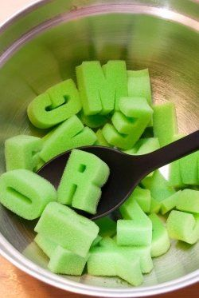
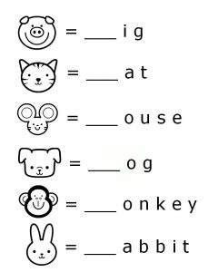
Activities/Procedures:
Activity:
All the students will come to the literacy center in small groups and work with letter flash cards sounding out the letter and then combining letters to make words and practicing sounding those out as well. When students are done with the flash cards they will work on a phonics worksheet where they have to write the first letter of the word to get it right.
Read:
Cookadoodledo! by Janet Stevens and Susan Stevens Crummel
Discussion:
Before:
Has anyone used a cookbook or recipe before? Students will yes and no. Can someone tell me in their own words what a cookbook or recipe are? I will accept several students’ response. Good job everyone a recipe is like instructions for what you cook.
During:
Several different times during the reading I will ask students what they think will happen next or how they think the book will end.
After:
Did the book end how you thought it would end? I will wait for the student’s response. Did you recognize any words from the book that we worked on today? Do any students remember any of the animals from the book? We will wait for response like hen, pig, turtle. I will then ask the student if they remember any of the ingredients from the recipe like sticks of butter and milk.
Activity:
After the group discussion the students will go back to their desk, and get with their desk partners and do alphabet soup. They will sound out the letters and form different words with the letters and write them down. After the students write down all their words they will read them out loud to their partner and to the instructor.

Activity:
When all the students are done with alphabet soup they will be given materials for each student to make their own recipe. When all the students are done with their recipe cards they will present them to the class, after they are all done the instructor will copy them and distribute all the students the class cookbook.

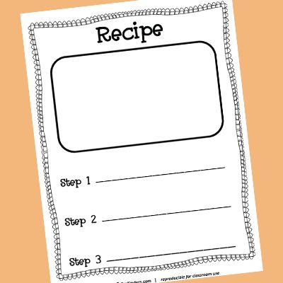

Reflections and Documentation/Evidence of Lesson Effectiveness
I would want to be more knowledgeable about the ELPS and CCRS so that I can incorporate them better into lesson plan. I also would want to find better ways to incorporate technology in my lesson plan.

