UNT Lesson Plan Template

Pre-service Teacher: | Grade(s):  1st | School/Mentor Teacher (if applicable):  Dr. Eutsler
Subject area(s):  Language Art and Reading  Math  Art | Unit Topic/Theme:  Phonological Awareness  Decoding words  BME | Lesson Title:  Decoding Words and BME with Creepy Carrots by: Aaron Reynolds
Find the TEKS, ELPS, and CCRS standards at this link:
http://www.teksresourcesystem.net/module/standards/Tools/Search
Relevant TEKS:  §110.3. English Language Arts and Reading, Grade 1, Adopted 2017. (b)(2)(A) demonstrate and apply phonetic knowledge by:  (i) decoding words in isolation and in context by applying common letter sound correspondences.  (b)(7)(C) describe the elements of plot development, including the main events, the problem, and the resolution for texts read aloud with adult assistance  (b)(7)(D) retell texts in ways that maintain meaning  (b)(12)(A) dictate or compose literary texts, including personal narratives and poetry.  §111.2. Kindergarten, Adopted 2012.  (b)(1)(E) Create and use representations to organize and record mathematical ideas  §117.105. Art, Grade 1, Adopted 2013.  (b)(2)(B) Place components in orderly arrangements to create designs. | Relevant ELPS:  §74.4. English Language Proficiency Standards.  (d)(2)(B)(i) are able to express simple, original messages, speak using sentences, and participate in short conversations and classroom interactions; may hesitate frequently and for long periods to think about how to communicate desired meaning;  (d)(3)(B)(i) demonstrate limited comprehension (key words and general meaning) of grade-appropriate stories read aloud in English.  (d)(3)(B)(iii)(II) struggle with some sounds in English words and some sound-symbol relationships due to differences between their primary language and English. | Relevant TX CCRS:  II.Reading  - Locate explicit textual information, draw complex inferences, and analyze and evaluate the information within and across texts of varying lengths.  9. Identify and analyze how an author’s use of language appeals to the senses, creates imagery, and suggests mood.  - Understand new vocabulary and concepts and use them accurately in reading, speaking, and writing  - . Identify new words and concepts acquired through study of their relationships to other words and concepts.
Lesson Objective(s)/Performance Outcomes
Objectives:
How will sounding out the letters of a word help the reader with new vocabulary?
Why is it beneficial to find the beginning, middle, and end to a story?
How will writing your own version of the story help you understand it?
Performance Outcomes:
Students will be able to pronounce words with the help of sounding out the letters.
Students will be able to recall the beginning, middle, and end of the story.
Students will be able to write their own version on how they would stop the Creepy Carrots.

Assessment (Description/Criteria)
Formative: Ask students before, during, and after discussion questions of the story. Students will assess themselves on whether or not they can read words, and if they can’t they will use decoding to help them pronounce the word. The last activity of the day for the students would be to write or draw in their Learning Logs and reflect on what they learned that day.

At the end of the lesson the students will play a game of Kahoot! So they can assess their knowledge on the story.

Materials and Resources
Book:
- Creepy Carrots by: Aaron Reynolds
Activities:
- Beginning, Middle, and End
- How to stop the Creepy Carrots- Toontastic app edition
- Creepy Carrots card game
- Carrot Trail math worksheet/game
- Creepy Carrot art

Other Materials:
- Ipad
- Kahoot!
- Construction paper
- Glue
- Googly eyes
- Scissors
- Paper fasteners (for spinner on math worksheet)
- Creepy Carrots Read-aloud

Management of the Instructional Environment
Students will have a designated circle time area for group time.
Once we have finished reading the book they will go into their 5 centers to do their activities, the centers are set up on their desks and the lounge areas around the room.
After they have circulated around all of the activities they will go back to their desks to play the game of Kahoot!
Technology Integration
Ipad will be used to make their own Toontastic of how they stopped the Creepy Carrots and at the end of the lesson when the class plays a game of Kahoot!

Diversity and Equity (Accommodations, Modifications, Adaptations)
When giving directions to the class, leave a pause between each step so student can carry out the process in their mind. On the back of the flash cards provided in the Creepy Carrot bag there will be pictures so ELL’s are able to connect the word with an image. An ELL or any student can also have a peer help them decode words if they are having trouble. The real-aloud will also be used for ELL’s to understand what is supposed to be felt in certain parts of the story. During the activities the teacher will assist students when needed.

Activities/Procedures
Read:
- Creepy Carrots by: Aaron Reynolds
Discussion:
Before-
- Can we predict what will happen in the story just by looking at the picture?
During-
- Why do you think the carrots started following Jasper Rabbit?
- Do you think Jasper Rabbit was scared of the creepy carrots?
After-
- What were the creepy carrots planning all along?
- Why couldn’t Jasper Rabbit’s parents see the creepy carrots?
- What happened in the beginning of the story?
- What happened in the middle of the story?
- What happened in the end of the story?
- Have you ever thought about your food being able to creep you out?
Centers:
Literacy-
- Beginning, middle, and end activity: The children will use pre-cut images of the story to rearrange on a magnetic friendly surface to demonstrate the beginning middle and end of the story.
http://deannajump.com/creepy-carrots-read-aloud-lessons/
- How to stop the Creepy Carrots- Toontastic addition: The students will create their own cartoon using the same storyline of Creepy Carrots, but instead they will make their own version on how they stopped the carrots from creeping them out using the Toontastic app on their iPads.
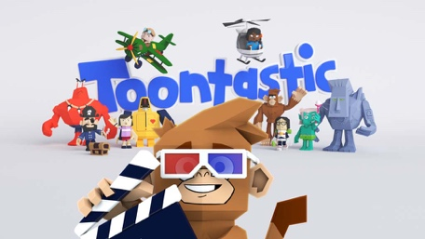
http://polkadotkinders.blogspot.com/2013/04/creepy-carrots-and-lets-get-aquainted.html
- Creepy Carrots card game: The game will start off with a 5 minute timer, the players will take turns picking a card from the bag. If they can read the card they will keep it, but if they can’t they will need to decode the word first then put it back. If a player picks the creepy carrot then they will need to put all of their cards back in the bag, the goal of the game is whoever has the most cards when the timer runs out, wins!
http://polkadotkinders.blogspot.com/2013/04/creepy-carrots-and-lets-get-aquainted.html
Math-
- Carrot Trail math worksheet/game- The students will make a spinner out of paper, fastener, and an arrow. They will each take turns spinning their spinner, whatever number they get they will need to color in that number of carrots on their worksheet, whoever gets to the end of the carrot trail, wins!
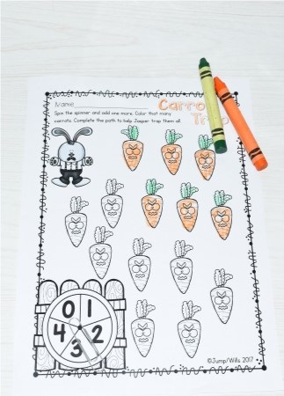
Art-
- Creepy Carrot art- The students will make their own creepy carrot out of construction paper, googly eyes, and glue.
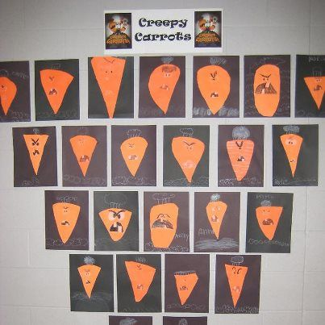
https://www.pinterest.com/pin/201606520794808417/
Group Game:
At the end of the lesson, the students will gather at their desks and get ready to play a game of Kahoot!, they will use the iPads provided to them. This will help the students recall the story and it will help the teacher see if the lesson was successful.

Reflections and Documentation/Evidence of Lesson Effectiveness
The process of writing this lesson plan was exciting and overwhelming, only because there are a variety of directions you can go with this story. I used English language arts, reading, math, and art because I felt that the activities would be interactive and a fun way of learning for the students. To improve my lesson in the future I would want to use the students’ creative writing to assess their writing skill and grammar, it will allow me to see which students need more help and which students are ahead of the plan. With this information, I can have activities to fit all of my student’s needs.

