Pre-service Teacher:  Lauren Maness | Grade(s): 5th Grade life skills classroom SPED | School/Mentor Teacher (if applicable):
Subject area(s):  Reading, Writing, Art, life skills, transitioning | Unit Topic/Theme:  Dealing with change and understanding grammar lesson | Lesson Title:  Overcoming Change and mastering Upper Case letters with Lenny and Lucy
Find the TEKS, ELPS, and CCRS standards at this link:
http://www.teksresourcesystem.net/module/standards/Tools/Search
Relevant TEKS:  §110.7. English Language Arts and Reading, Grade 5, Adopted 2017.  1) Developing and sustaining foundational language skills: listening, speaking, discussion, and thinking--oral language. The student develops oral language through listening, speaking, and discussion. The student is expected to:  (A) listen actively to interpret verbal and non-verbal messages, ask relevant questions, and make pertinent comments;  (D) work collaboratively with others to develop a plan of shared responsibilities.  (4) Developing and sustaining foundational language skills: listening, speaking, reading, writing, and thinking--fluency. The student reads grade-level text with fluency and comprehension. The student is expected to use appropriate fluency (rate, accuracy, and prosody) when reading grade-level text.  (7) Response skills: listening, speaking, reading, writing, and thinking using multiple texts. The student responds to an increasingly challenging variety of sources that are read, heard, or viewed. The student is expected to:  (A) describe personal connections to a variety of sources, including self-selected texts;  (C) use text evidence to support an appropriate response;  (E) interact with sources in meaningful ways such as notetaking, annotating, freewriting, or illustrating; | Relevant ELPS:  §74.4.D.1.A.i  (i) struggle to understand simple conversations and simple discussions even when the topics are familiar and the speaker uses linguistic supports such as visuals, slower speech and other verbal cues, and gestures;  §74.4.D.1.A.iii  (iii) may not seek clarification in English when failing to comprehend the English they hear; frequently remain silent, watching others for cues. | Relevant TX CCRS:  Reading:  - Identify explicit and implicit textual information including main ideas and authors purpose.  - Identify and analyze how an authors use of language appeals to the senses, creates imagery, and suggests mood.  Listening:  - Listen and actively engage in group discussions  - Listen critically and respond appropriately to presentations  Identify analyze and evaluate similarities and differences in multiple text presents information argue position are related themes
Lesson Objective(s)/Performance Outcomes
Objectives:
- What is it going to be like transitioning to middle school and making new friends?
- How can we use a book to express our feelings?
- Can the students tell from the story that the main character is happy? Sad? Scared?
Performance:
- Students will be able to identify the different parts of the story using a story board (different pictures in the story put in order on a board usually has Velcro).
- Students will be able to draw a picture of one of the feelings one of the characters express. And will be able to verbally tell what the emotion is and who the character is that expressed that emotion/feeling.
- Students will be able to identify the beginning of sentences based on punctuation and capitalization at the beginning of the sentence.

Assessment (Description/Criteria)
Formative: First students will be taught information about capitalization and punctuation. They will be given a motor skill activity that has them match the lower case letters to the upper case letter (document attached). Students will be asked questions about what they think moving to middle school will be like. If any of them have ever moved to a new house and how it made them feel. Students will draw a picture of what they think middle school will look like and write one or two words expressing how middle school makes them feel.
Summative: Collect the pictures of the character and his feeling. Students should be able to verbally say the characters name or point him/her out in the book. Students will also be given two pages from the book and with help, highlight the capitalized word at the beginning of all the sentences with one color and the punctuation with another color. This will see if the student is understanding the difference in lower case and upper case and what punctuation looks like. If the student is not understanding it more time can be spent helping them master this skill.

Materials and Resources
Book:
- Lenny & Lucy By Philip C. Stead
Activities:
- http://theimaginationtree.com/2014/07/matching-alphabet-beans-literacy-game.html or https://www.pinterest.com/pin/AVZG49AULmvJLnXBL5kccUNO-TGAv2iNmphLxcKac6Qei_A_cVI-r44/ depending on fine motor skill needs
- Drawing of middle school
- Drawing of character and his emotions.
Other Materials:
- iPads
- Crayons and markers
- Emotion cards
- Highlighters

Management of the Instructional Environment
Students will start out at the desks to do the initial punctuation and grammar part of the lesson. (5 minute break) Then they will be questions and draw their picture while still at their desks. After they draw their pictures they will up load them to seesaw.
Students will sit in the reading area for story time
Students can return back to their seats to draw or pick somewhere else in the room to draw their characters. These will be uploaded to seesaw as well.
The book pages come next
Then everyone will come back to the reading center to summarize what we have learned today

Technology Integration
iPad or computer or phone to use Seesaw to upload their art work online for their class and parents to see it.
Students can use the iPads to help them spell words.
Assistive technology to help students share their ideas and thoughts when they can do so verbally

Diversity and Equity (Accommodations, Modifications, Adaptations)
Emotion charts will be available for students to help them identify the behaviors in the book and to help with spelling for their art work.
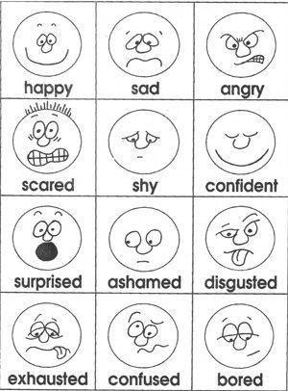
Ask level one and two question throughout the story to check understanding and ensure students are paying attention (good for students with ADHD or ADD)
Words can be written by the teacher first and students can trace over them.
Communication Apps can be used to answer questions if the student cant answer the question verbally.
The book pages can be read to the student and hand over hand can be used to help them highlight the correct letter and punctuation.
Students can take a break in between activities if they are overwhelmed or tired.
Teachers can help students, hand over hand, take pictures of their art work and help by giving verbal promts to upload it onto the computer

Activities/Procedures
Read:
Lenny and Lucy
Discussions:
Before-
- How many of y’all have moved to a new house? How did it make you feel?
- You guys are about to go to middle school! Are you excited or nervous?
During-
- Does anyone else have a dog? What’s their name?
- Do you have a stuffed animal that makes you feel safe?
- Can we predict if Lenny is going to make Peter feel safer?
- Do you guys ever get lonely? What do you do when you get lonely!
After –
- What are ways that we can be friends to new people at our new school?
- What was your favorite part of the story?
- How long do you think Lenny and Lucy will live outside protecting the house?
- How did the pictures help tell the story?
Centers:
Fine motor skills/Lower case vs. Upper case-
Clothes pin matching activity: Children will practice their fine motor skills will working on matching lower case letters to upper case letters. An adaption to this is below it. This uses stones for children who are working on different motor skill skills.
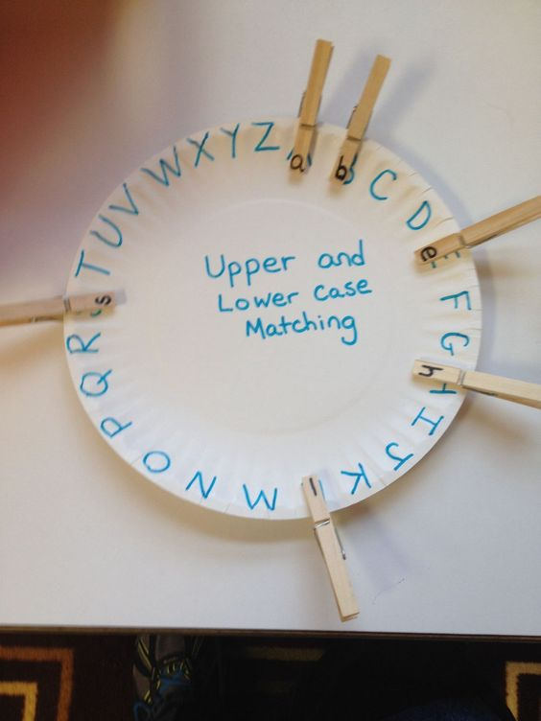
Art –
- Middle School Drawing: Give students paper, crayons, makers and colored pencils. Have them draw what they think the middle school looks like and underneath write one or two words that describes middle school
- Character drawing and Emotion description: Have students get another slip of paper and draw a picture of their favorite character from the book. They must know the name of the character and write how the character is feeling underneath the picture
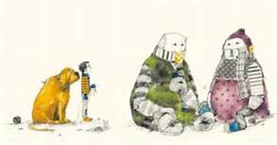
Literacy-
- Students will be given two pages of the story to highlight the upper case letters in the story. They will also need to highlight the punctuation.
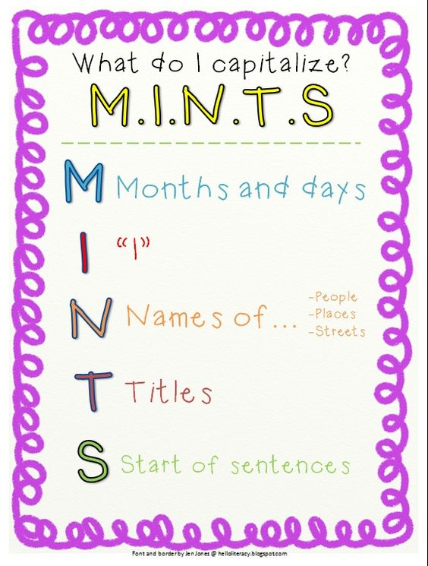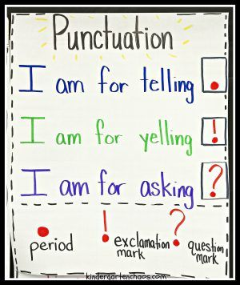
Technology:
- Working with computers/iPads students will work on taking pictures of their art work and posting them to the Seesaw account for their parents to see.
Group Activity:
- After everyone has completed their work they will all come back to the reading center and reread the story. Then they will talk about what they have learned today and how it will help them in their future transitions. Students will get to show off their art work here and ask any questions they had about the book or about transitioning.
Reflections and Documentation/Evidence of Lesson Effectiveness
This book had many different avenues I could use to come put with lesson plans. There were no previous lesson plans done for this book so a lot of the work I did myself. But I found a lot of fun activities on Pinterest to tie into the lesson. I integrated Upper case vs. Lower case and punctuation into my lesson because that is something that is very important for children especially those one in SPED to understand. Students with special needs still need to be taught they just need more adapted assignments. My lesson plan has a ton of adaptations that could be easy implemented in a special education classroom. This makes the lesson more effective for more students. This will be a great way for students to integrate their transition goals in with their daily reading and writing goals.

