UNT Lesson Plan Template

Pre-service Teacher:  BA | Grade(s):  1st grade | School/Mentor Teacher (if applicable):  EDRE 4450 Dr. Eutsler
Subject area(s):  English Language Arts and Reading | Unit Topic/Theme:  Read Aloud | Lesson Title:  Making Predictions and Exploring Characters with “Creepy Carrots”
Find the TEKS, ELPS, and CCRS standards at this link:
http://www.teksresourcesystem.net/module/standards/Tools/Search
Relevant TEKS:  English Language Arts and Reading, Grade 1  §110.12.(b).4 (C) Students comprehend a variety of texts drawing on useful strategies as needed. Students are expected to establish purpose for reading selected texts and monitor comprehension, making corrections and adjustments when that understanding breaks down (e.g., identifying clues, using background knowledge, generating questions, re-reading a portion aloud). | Relevant ELPS:  ELPS.b.2  Provide instruction in the knowledge and skills of the foundation and enrichment curriculum in a manner that is linguistically accommodating commensurate with the student’s levels of English language proficiency to ensure that the student learns the knowledge and skills in the required curriculum | Relevant TX CCRS:  E/LAS.II.A.7  Evaluate the use of both literal and figurative language to inform and shape the perceptions of readers.
Lesson Objective(s)/Performance Outcomes
Lesson Objectives:
- How does the author develop a character?
- How do we know what will happen in a story?
- Can the students make a prediction about what will happen next?
- Can the students identify different characteristics of different characters in the story?
Performance Outcomes:
- Students will be able to make inferences about what will happen throughout the story by illustrating different parts of the story we read in circle time.
- Students will be able to make predictions after reading portions of the story by discussing their thoughts during group time.
- Students will be able to identify different characters in the story by creating a character map.

Assessment (Description/Criteria)
Formative: Discuss story before, during and after story in group setting. Record who actively participates in discussion. Focus on making predictions and making connections.

Collect drawings and assess children’s knowledge by looking at their drawings. This will show you who is struggling in different literacy areas. Hopefully this will help you narrow down the weaknesses in the classroom and help you know what to focus on.

Materials and Resources
Book:
“Creepy Carrots” by Aaron Reynolds

Materials:
Paper
Crayons

Activities:
http://deannajump.com/creepy-carrots-read-aloud-lessons/

Management of the Instructional Environment
Student will begin on the reading rug while we read the story.
After we read the story and have discussion, students will go to their desks and perform different tasks alone and in group centers.
When finished with center time the teacher will transition students back to the reading rug to have a final discussion.

Technology Integration
Use Ipad or computers in one center, use sentence structure and literacy development games

Diversity and Equity (Accommodations, Modifications, Adaptations)
Provide detailed explanations and explain any new vocabulary words used during the group discussion before centers. Assist ELLs during center time, as needed.

Activities/Procedures
Read:
Creepy Carrots by Aaron Reynolds

Activity:
Have students color and cut out parts of the story. In one center, students will rearrange the story parts and retell the story in their own words.

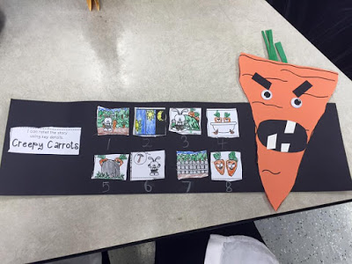
In another center we will focus on interactive writing/phonics. Here we will have a worksheet that has different words with the same word ending. Here they will identify the ending and glue together different words on their papers.
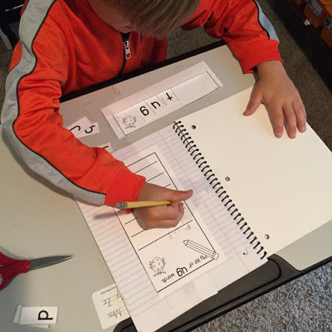
In another center we will use the Ipads to explore different phonics games to strengthen their literacy development through onset rime and rhyming words.

Students will create their own character map. They will have the characters name in the middle and branches will include details about the character that they thought were important to the story.
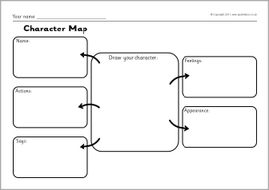
Reflections and Documentation/Evidence of Lesson Effectiveness
The story itself is a cute story and it allows for so many different lessons. I chose this lesson because it’s a silly fiction story that the kids will love and be interested in. Stories like this always offer a great number of assessments you could use. There were many opportunities to introduce new concepts, like main character and prediction.

