UNT Lesson Plan Template
Pre-service Teacher: N/A | Grade(s): Kindergarten | School/Mentor Teacher (if applicable): N/a
Subject area(s):  Science | Unit Topic/Theme:  Germs & Cleanliness | Lesson Title:  “Sick Simon”
Relevant TEKS:  §112.11. Science, Kindergarten, Beginning with School Year 2010-2011.  (b) Knowledge & Skills  (1)(B) discuss the importance of safe practices to keep self and others safe and healthy; and | Relevant ELPS:  §74.4. English Language Proficiency Standards.  (3)(B) expand and internalize initial English vocabulary by learning and using high-frequency English words necessary for identifying and describing people, places, and objects, by retelling simple stories and basic information represented or supported by pictures, and by learning and using routine language needed for classroom communication; | Relevant TX CCRS:  Science Standards  VI. Biology  A. Structure & Function of Cells  1. Know that although all cells share basic features, cells differentiate to carry out specialized functions.
Lesson Objective(s)/Performance Outcomes
Objectives:
Questions define biology vocab (protozoa, virus, etc.) as well teach how to get sick and how the process of healing.
- “How can someone get sick? How do we get better? How do we prevent from get sick? Etc.”
- “What should we do when we get sick? What are those germs & what do they do?”
Performance Outcomes: Learning Goals (see Lesson Plan: Essential Qs vs. Learning Goals on BB Content)
- Students will be able to describe the main germs and their functions.
- Students will be able to describe how one gets sick and how to apply safe and healthy practices.
Assessment (Description/Criteria)
Formative technique(s):
- Questioning/Discussion/Observation: ask questions, discuss through elaboration of responses, and observe their responses.
- Performance Task: completing painting germs on hands and washing them away while participating in discussion assessment.
- Draw pictures on “Roll a Response” worksheet to see student’s understanding of what happens in a story as a group.
Materials and Resources
Book: “Sick Simon” by Dan Krall
Materials:
- “Roll-A-Story” (Worksheet below) https://www.pinterest.com/pin/239887117623679268/
- Aprons, Colored paint & paint brushes
- Soap, wash cloth, & Hand sanitizer
- Poster board of “How to wash your hands”
- https://www.pinterest.com/pin/463730092866923511/ (poster below)
- IPad (read aloud) - https://www.youtube.com/watch?v=uEUKsdBE3-Q&t=10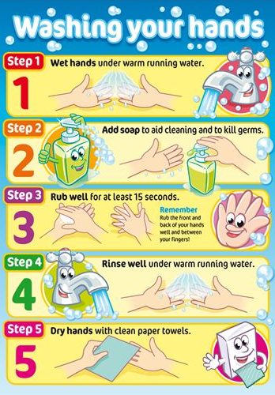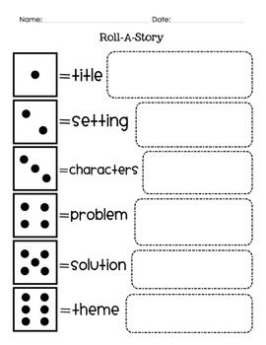
Management of the Instructional Environment
- Open space (Reading Rug)
- Neat tables & Chairs w/activity materials already placed on tables.
- Sink area is clean & prepped with soap, towel & hand sanitizer.
- Put up ‘washing your hands’ poster in appropriate view.
- Have drawings of germs & their names by Reading Rug and by Tables or hung on white board.
- Whole group
Technology Integration
- IPad for read aloud.
- Show a picture of different germs and their names on the screen while children are doing painting part of activity
Diversity and Equity (Accommodations, Modifications, Adaptations)
- ELL’s – prepare beforehand vocab translation and introduce that vocab to students to help connect ELL’s with the whole class. Integrate culture on how other’s get better based on their background.
- Gifted – Introduce more complex vocab, germs, scientific processes of what/how germs affect others.
- IEP – Read with student 1-1, do activity with student, be more attentive, activity meet’s child’s needs.
- 504 – Make sure students are able to see book by being up closer or taking picture of the book pages and putting them on a PowerPoint and read to students on PowerPoint. If child has hearing difficulties, record read aloud and put in CD player/Cassette tape for them to hear with appropriate volume.
Activities/Procedures
Before:
- Prep all materials
- Gather students to ‘Reading Rug’ w/the song: “Let’s all go to the Reading Rug, the reading rug, the reading rug, let’s all go to the reading rug for a really fun time”
- Introduce book w/questions & discussion about the book: “What do you think this book is about? Does anyone know how we get sick? How do we get better? Who takes care of you when you’re sick? Etc.”
- Read book with read aloud while pausing story to enticing questions, vocab, & discussion: “How is Simon sick? What does being sick look like? What germs does Simon meet? How does Simon feel better? How do you feel when you’re sick? How do you get better? Etc.”
During:
- After reading the book, discuss what happened in the story.
- Go to the tables for an activity and instruct students to put on aprons.
- Next instruct students to paint ‘germs’ on their hands while instructing the colors are different colored germs from book (e.g.: yellow-virus, purple-protozoa, etc.)
- After hands covered in paint, go to hand washing station (2 at a time)
- Instruct students how to wash their hands: turn on sick & wet hands, get soap, scrub while singing ‘ABC’song, rinse hands & turn off sink, wipe hands, and apply hand sanitizer (optional).
- Put away apron & return to Reading Rug to wrap up this lesson with an activity.
After:
- Summarize students’ learning & experiences “How can we get sick? What makes us sick? How do we get better? How do our parents make us feel better (integrate culture and backgrounds in discussion)? Etc.”
- Introduce other books about germs: “Germs” – Judy Oetting “Come Clean for School – Berenstain Bears” – Jan&Mike Berenstain
- Clean up materials.
Reflections and Documentation/Evidence of Lesson Effectiveness
- Reflect on how I could bring in other resources to integrate different learning strategies such as bringing in a microscope and see different bacteria.
- Bring in more visuals that encourage reading & writing such as “how to wash your hands” and other health practices such as covering your mouth when coughing, wash your hands for eating or after using the restroom, etc.
- Integrate more technology IPads such as doctor cleaning game apps, clinic kid apps, etc.
- Apply dramatic play of a doctor’s office/clinic.

