UNT Lesson Plan Template
Pre-service Teacher:  Stephanie Newman | Grade(s):  1st grade | School/Mentor Teacher (if applicable):
Subject area(s):  Language Arts and Reading, Fine Arts, and Science | Unit Topic/Theme:  Read Aloud | Lesson Title:  Is It Worth the Wait?
Relevant TEKS:  §110.3. English Language Arts and Reading  (1) Developing and sustaining foundational language skills: listening, speaking, discussion, and thinking--oral language. The student develops oral language through listening, speaking, and discussion.  (A) listen actively, ask relevant questions to clarify information, and answer questions using multi-word responses;  §117.105. Art  (b) Knowledge and skills.  (4) Critical evaluation and response. The student responds to and analyzes artworks of self and others, contributing to the development of lifelong skills of making informed judgments and reasoned evaluations.  (A) explain ideas about personal artworks;  §112.12. Science  (8) Earth and space. The student knows that the natural world includes the air around us and objects in the sky.  (B) observe and record changes in the appearance of objects in the sky such as clouds, the Moon, and stars, including the Sun; | Relevant ELPS: (Texas English Language Proficiency Standards)  §74.4.  (c) Cross-curricular second language acquisition essential knowledge and skills.  (1) Cross-curricular second language acquisition/learning strategies. The ELL uses language learning strategies to develop an awareness of his or her own learning processes in all content areas. In order for the ELL to meet grade-level learning expectations across the foundation and enrichment curriculum, all instruction delivered in English must be linguistically accommodated (communicated, sequenced, and scaffolded) commensurate with the student's level of English language proficiency. The student is expected to:  (A) use prior knowledge and experiences to understand meanings in English; | Relevant TX CCRS:  II. Reading  A. Locate explicit textual information, draw complex inferences, and analyze and evaluate the information within and across texts of varying lengths.  D. Explain how literary and other texts evoke personal experience and reveal character in particular historical circumstances.  IV. Listening  A. Apply listening skills as an individual  and as a member of a group in a variety  of settings (e.g., lectures, discussions, conversations, team projects, presentations, interviews).  I. Nature of Science: Scientific Ways of Learning and Thinking  A. Cognitive skills in science
Lesson Objective(s)/Performance Outcomes
Objectives:
Why is it important we pay attention to the clouds, the Moon, and the stars?
How does art change your thinking about the world?
Why is it important to listen carefully and ask questions when we read as a class?

Performance Outcomes:
Students will create their own telescope to be able to look at the moon, the stars, and the clouds.
Students will be able to create their own version of how they see the stars.
Students will be able to answer questions from the book and be able to make predictions.
Assessment (Description/Criteria)
Formative: The teacher will ask students questions about waiting for something. The teacher will make sure each and every student has a turn to answer the question. Throughout the story, the teacher will make sure to be asking questions about the events in the book. Once the book is finished, the teacher will close the reading time with ending questions to make sure students were paying attention.

Students will be asked during their literacy center to fill out worksheets about the book they were just read aloud. Once students are finished with their worksheet assignments, they will be asked to write a short story using their imagination and thinking skills of how the story would go differently if Piggie had not waited to tell Gerald the surprise. This will show the teacher which of the students are more advanced with their listening and writing skills and who are struggling and may need some help.

Materials and Resources
Book:
- Waiting Is Not Easy! By Mo Willems

Activities:
- ART- https://playgroundparkbench.com/constellation-sensory-play/
- SCIENCE- http://www.123homeschool4me.com/2016/05/solar-system-moon-unit.html (will have telescopes already made, the students will decorate and color the telescope to take home and look at the moon and stars).
- LANGUAGE ARTS- http://applefortheteach.blogspot.com/2014/03/roll-and-retell-building-summarizing.html and http://www.classroomfreebiestoo.com/2013/02/listening-response-sheets.html

Other Materials:
- Dice for first literacy lesson
- Zip lock bag, confetti stars, and sport styling gel for art lesson
- Glue, markers, and confetti for decorating/ coloring for the science lesson

Management of the Instructional Environment
The class will start off reading time by sitting in a circle and will go around answering questions.
Once the story is finished, the teacher will break off the students into centers by grouping them according to the color of their shirt. (When students do group work, the teacher assigns groups differently each time based on fun ideas such as t-shirt, favorite animal, favorite time of day, etc.)
Once centers are finished, the teacher will call the students back to the floor to end the lesson.
Technology Integration
For extra inspiration when students are creating their starry night and telescope, the teacher will show on the monitor different examples of stars, the moon, and clouds.

Diversity and Equity (Accommodations, Modifications, Adaptations)
Difficult words like surprise, groan, waiting, and wasted in the book will be highlighted and drawn to explain and show to ELL’s who may not know what the word is or have never seen it before.

Activities/Procedures
Read:
- Waiting Is Not Easy! By Mo Willems
Discussion: 30 minutes
Before:
- Do you think it is worth waiting for something or do you prefer to know right away?
- How many of you have read or have heard of this book before?
During:
- What do you think is the reason for Piggie wanting to wait for the surprise?
- Has anyone ever made you wait for a surprise?
- Why do you think Gerald is feeling so tense and nervous?
- What emotions and feelings do you feel when you have to wait for something?
- Why do you think Piggie is waiting so long to tell the surprise?
- How long have you ever waited for a surprise?
After:
- Was Piggie’s surprise worth waiting for?
- Why do you think it is important not to rush something?
- What happened when Piggie told Gerald the surprise?
- What do you think the purpose of the story was?
- What do you think would happen if Piggie told Gerald the surprise instead of waiting?
- What kind of surprise have you waited for? Have the students share their experiences.
Centers:
Literacy Center- 20 minutes
- Students will first fill out the Listen to Reading worksheet and then play the Roll & Retell game.

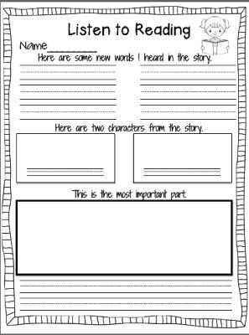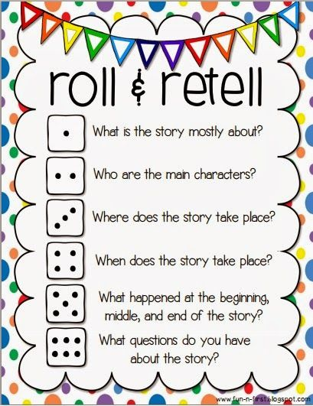

Art Center- 20 minutes
- Students will make their own starry night by mixing confetti stars and gel into a zip lock bag.
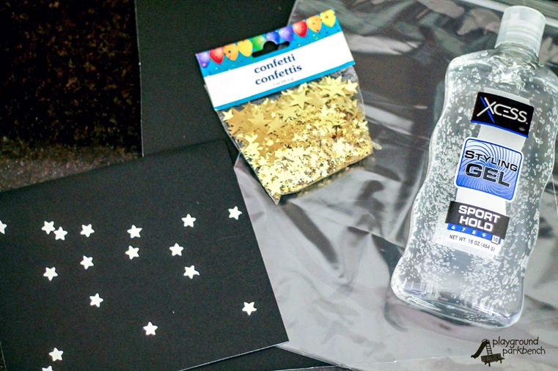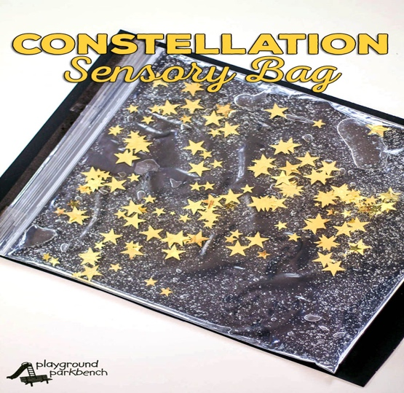

Science Center- 20 minutes
- Students will decorate, color, and customize their own telescope to take home and observe the stars, the moon, and the clouds. The teacher will already provide the telescope built (duct tape and cardboard).
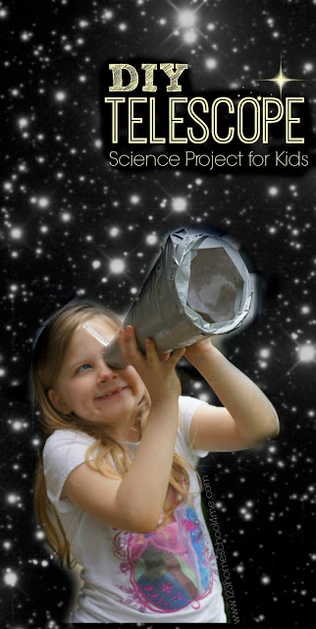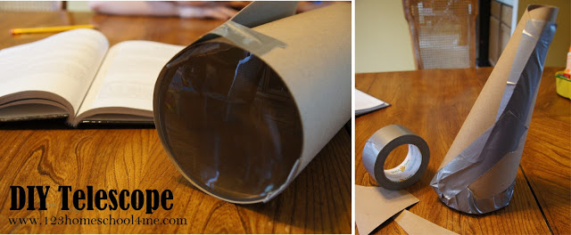

Reflections and Documentation/Evidence of Lesson Effectiveness
What is great about this book is how many different lessons you can create for your students. After reading the book, I decided to integrate language arts, fine arts, and science incorporating reading aloud. With each center, I formed multiple questions for students to make predictions before the story, during the story, and after the story. They will be able to really think about the questions and relate them to their personal life, their experiences, and how they perform their task at each center. At the end of each center, we will all gather on the floor to reflect on what we have learned, what stood out to each person, and share more experiences.

